**HOTEL MANAGEMENT SYSTEM**



|  |
| --- |
| **Table of the Concepts:** |

# **1.Executive Summary**

##### 1.1 Project Overview

##### **2.Product/Service Description**

###### 2.1 Product Context

###### 2.2 User Characteristics and their Goals

###### 2.3 Assumptions

###### 2.4 Constraints and Dependencies

##### **3.Requirements**

###### 3.1 Functional Requirements

###### 3.2 Non-functional Requirements

###### 3.2.1 Product Requirements

###### 3.2.1.2 Additional Product Non-Functional Requirements

###### 3.2.2 Organizational Requirements

###### 3.2.3 External Requirements

###### 3.2.3.3.1 Accounting Requirements

###### 3.2.3.3.2 Security Requirements

###### 3.2.4 Domain Requirements

##### **4.Use Cases**

###### 4.1 User Scenarios Extended

###### 4.2Use Cases

###### 4.3 Use Cases Diagrams

##### **5.Diagrams**

###### 5.1 Erd Diagram

###### 5.2 Activity Diagram

###### 5.3 Class Diagram

###### 5.4 State Diagram

###### 5.5 Sequence Diagram

**1.Executive Summary**

**1.1 Project Overview**

The Hotel Management System (HMS) project has a goal to create an all-inclusive software program that will automate and streamline a variety of hotel functions, hence boosting guest satisfaction, staff productivity, and overall efficiency. The system would combine important features including housekeeping, billing, reservations, front desk operations, and reporting onto a single platform, giving hotels an effective management tool. Hotels nowadays are focusing on maximizing their revenues as all other businesses do and the main reason for that is the ever-increasing competition. The online world has made it difficult for hotels and resorts to compete by providing guests a plenty of choices including Homestay, Hostel with bunk beds or even a modular option. Therefore, there is an increasing demand for best hotel management system to facilitate the management of hotel operations and functions. Operating a successful hotel business today is a challenge. A hotelier must manage various of proposals such as operations, staff and maintenance, meanwhile keeping costs under control and balances as it is one of the most important and critical issues for a hotel business to increase their revenues and to compete with other hotels. To improve the efficiency of this process, a good hotel management system which uses the modernizing techniques must be provided. The key to reaping the benefits of an effective hotel management software system is to select the right one for your property. It’s critical that you know exactly what this hotel management technology is, and why it is important for you to implement it at your hotel. These days every person can find different options of the hotel reservation software free on the internet, however one must judge the solution with the quantum of features and quality that it is providing. There should be a complete functionality as a hotel management system can be both basic and advanced based on the pricing options that are available as well. Also, we can say that the developers are making such software as per the pocket of the business and this is one of the main reasons why we have so many different options in the online world. Hotelmanagement is a key element for a very important branch of economy, which is tourism. Knowing this, two members of our group were familiar with different types of management software, and they had analysed the deficiencies that they have and decided to make this project based on the improvement of these deficiencies. Our software aims to have all the features that a hotel needs to adapt to the management structure of the business, and by making practical and effective use of these features every hotelier’s work life will be much easier than they have ever imagined by using this product.

# **2.Product/Service Description**

Hotels nowadays differ in size, culture and management structure. So, the perfect Software provided, needs to be adapted to specific business which will implement and use it. Hotel Management System is a web application which aims to facilitate the management system of a hotel. It will keep track of hotel reservations, rooms to be cleaned and so much more.

**2.1 Product Context**

With the use of this technology, hotel owners and operators may increase both short- and long-term bookings while streamlining administrative work with the help of the Hotel Management System (HMS). HMS is a crucial component of the entire visitor experience, not only for daily operations. The hotel management system must improve the customer experience with the brand from the start of the guests' online booking process to the end of their stay and their feedback after they return home. The goal of this solution is to unite all potential Hotel stakeholders while providing flexibility and streamlining the management process. The primary goals of the product are reliability and ease of use.

**2.2 User Characteristics and their Goals**

|  |  |  |
| --- | --- | --- |
| **User** | **Characteristics** | **Goals** |
| Admin | Administrator of the HMS (Hotel Management System). | - See booked rooms.  - Add/Remove users.  - Observe statistics and inventory. |
| Front Desk | Handles guest check-ins, check-outs, and phone calls. | - View rooms to be cleaned.  - View available rooms for customers.  - Handle check-ins/check-outs.  - Make and view reservations.  - Access notifications. |
| Guest | Users interested in making reservations at the hotel. | - Make bookings.  - View if room is ready for stay.  - Modify booking details (dates, times).  - Edit credentials. |
| Housekeeping | Employees responsible for cleaning rooms. | - See rooms to be cleaned.  - Update room cleaning status (e.g., ready or not). |
| Manager | Person responsible for operational aspects of the hotel. | - View performance metrics and reports.  - Integrate marketing channels. |
| Accounting | Responsible for invoicing and billing. | - Manage invoicing and billing processes. |
| Facilitators | Provide required inventory for the hotel. | - Receive messages or send messages about inventory needs. |
| Staff Sponsored | Users with special privileges and access rights for administrative actions. | - Perform administrative tasks.  - Approve certain transactions. |
| Suppliers | Third-party vendors providing goods/services | - Interact with the system for procurement, stock management, and service delivery. |

###### **2.3 Assumptions**

1. All users' needs to have basic knowledge in English language and can know other language;

2. All users have basic knowledge in computer and smartphone usage;

3. Stakeholders of the hotel have basic knowledge on how to use the system due to previous

experiences with other systems;

4. Hotel is equipped with PC/Laptop/Tablet, printer, mobile phone;

5. Hotel must have internet connection all the time;

6. It is assumed that the Hotel provides Credit Card and Cash payments.

###### **2.4 Constraints and Dependencies**

1.All users must be logged in to use the product and to access the information

2. The system must follow all Albanian and international legal restrictions, regarding aviation regulations set by certain institutions.

# 3.Requirements

Requirements are the conditions or capabilities that a software system must have to satisfy the needs of its users, stakeholders, and the business. They define what the system should do and how it should perform, providing a clear framework for design, development, and testing. Requirements are essential for guiding the entire development process and ensuring the software meets its intended purpose.

**3.1 Functional Requirements**

|  |  |  |  |  |  |
| --- | --- | --- | --- | --- | --- |
| **Req#** | **Requirement** | **Comments** | **Priority** | **Date** | **SME Approved** |
| BR_LR_01 | Login Constraint.  Different Views for different controllers | All users have to be logged in depending on the user level | 1 | 5/2/2025 | Erta Llenga,Esta Cekrezi,Artemisa Hasalami,Ester Pashtranjaku,Megi Almadhi,,Arsildo Veliu,Brikena Papadhopuli |
|  | Different Views for different controllers | Depending on the user level | 1 | 5/2/2025 | Erta Llenga,Esta Cekrezi,Artemisa Hasalami,Ester Pashtranjaku,Megi Almadhi,,Arsildo Veliu,Brikena Papadhopuli |
| BR_LR_03 | Add/Remove users | The admin can add or remove users | 1 | 5/2/2025 | Erta Llenga,Esta Cekrezi,Artemisa Hasalami,Ester Pashtranjaku,Megi Almadhi,,Arsildo Veliu,Brikena Papadhopuli |
| BR_LR_04 | View booked rooms and check-in/check-out date | The admin and front desk have the ability to view booked rooms and check- in/check-out date | 1 | 5/2/2025 | Erta Llenga,Esta Cekrezi,Artemisa Hasalami,Ester Pashtranjaku,Megi Almadhi,,Arsildo Veliu,Brikena Papadhopuli |
| BR_LR_05 | The system should provide email notifications and assinged it with room and booking of room | The client will be notified with an email for each successful booking. Assigning rooms based on preference of the guest. | 2 | 5/2/2025 | Erta Llenga,Esta Cekrezi,Artemisa Hasalami,Ester Pashtranjaku,Megi Almadhi,,Arsildo Veliu,Brikena Papadhopuli |
| BR_LR_0 6 | Provide statistics | The admin can view a statistics tab | 3 | 5/2/2025 | Erta Llenga,Esta Cekrezi,Artemisa Hasalami,Ester Pashtranjaku,Megi Almadhi,,Arsildo Veliu,Brikena Papadhopuli |
| BR_LR_0 |  | Assigning rooms based on preference | 2 | 5/2/2025 | Erta Llenga,Esta Cekrezi,Artemisa Hasalami,Ester Pashtranjaku,Megi Almadhi,,Arsildo Veliu,Brikena Papadhopuli |
| BR_LR_0 8 | Notification Handling | E-mail system integrated and notifications regarding check-in/check-out or guest requests are accessible | 2 | 5/2/2025 | Erta Llenga,Esta Cekrezi,Artemisa Hasalami,Ester Pashtranjaku,Megi Almadhi,,Arsildo Veliu,Brikena Papadhopuli |
| BR_LR_0 9 | Reporting | Managers can access reports | 2 | 5/2/2025 | Erta Llenga,Esta Cekrezi,Artemisa Hasalami,Ester Pashtranjaku,Megi Almadhi,,Arsildo Veliu,Brikena Papadhopuli |
| BR_LR_1 0 | Performance Metrics | Manager can see their employee performances in a graphical manner | 2 | 5/2/2025 | Erta Llenga,Esta Cekrezi,Artemisa Hasalami,Ester Pashtranjaku,Megi Almadhi,,Arsildo Veliu,Brikena Papadhopuli |
| BR_LR_11 | Room Availability | Front Desk can see if room is available or not | 1 | 5/2/2025 | Erta Llenga,Esta Cekrezi,Artemisa Hasalami,Ester Pashtranjaku,Megi Almadhi,,Arsildo Veliu,Brikena Papadhopuli |
| BR_LR_12 | View Payment | Accounting can view payment | 1 | 5/2/2025 | Erta Llenga,Esta Cekrezi,Artemisa Hasalami,Ester Pashtranjaku,Megi Almadhi,,Arsildo Veliu,Brikena Papadhopuli |
| BR_LR_13 | Print Invoice | System prints daily, monthly, Or yearly invoices | 1 | 5/2/2025 | Erta Llenga,Esta Cekrezi,Artemisa Hasalami,Ester Pashtranjaku,Megi Almadhi,,Arsildo Veliu,Brikena Papadhopuli |
| BR_LR_14 | Monitor Occupancy and Revenue | Manager can see occupancy rates and revenue/revenue projections | 1 | 5/2/2025 | Erta Llenga,Esta Cekrezi,Artemisa Hasalami,Ester Pashtranjaku,Megi Almadhi,,Arsildo Veliu,Brikena Papadhopuli |
| BR_LR_15 | Market Segmentation | Manager can apply market segmentation based on guest preferences | 2 | 5/2/2025 | Erta Llenga,Esta Cekrezi,Artemisa Hasalami,Ester Pashtranjaku,Megi Almadhi,,Arsildo Veliu,Brikena Papadhopuli |
| BR_LR_16 | Notify Housekeeping | Notify housekeeping staff based on required rooms to be cleaned | 1 | 5/2/2025 | Erta Llenga,Esta Cekrezi,Artemisa Hasalami,Ester Pashtranjaku,Megi Almadhi,,Arsildo Veliu,Brikena Papadhopuli |
| BR_LR_17 | Notify Guest on room status | Guest gets notified on if room is cleaned | 2 | 5/2/2025 | Erta Llenga,Esta Cekrezi,Artemisa Hasalami,Ester Pashtranjaku,Megi Almadhi,,Arsildo Veliu,Brikena Papadhopuli |
| BR_LR_18 | User Account Creation | User creates account based on credentials | 1 | 5/2/2025 | Erta Llenga,Esta Cekrezi,Artemisa Hasalami,Ester Pashtranjaku,Megi Almadhi,,Arsildo Veliu,Brikena Papadhopuli |
| BR_LR_19 | Reservation Modification | Guest can modify reservation date or specific reservation request | 1 | 5/2/2025 | Erta Llenga,Esta Cekrezi,Artemisa Hasalami,Ester Pashtranjaku,Megi Almadhi,,Arsildo Veliu,Brikena Papadhopuli |
| BR_LR_20 | Feedback Submission | Guest submits feedback after stay. Feedback provided by the client is successfully recorded and stored in the system for analysis | 3 | 5/2/2025 | Erta Llenga,Esta Cekrezi,Artemisa Hasalami,Ester Pashtranjaku,Megi Almadhi,,Arsildo Veliu,Brikena Papadhopuli |
| BR_LR_21 | Cancellation Request | Guest can request cancellation before due date | 1 | 5/2/2025 | Erta Llenga,Esta Cekrezi,Artemisa Hasalami,Ester Pashtranjaku,Megi Almadhi,,Arsildo Veliu,Brikena Papadhopuli |
| BR_LR_22 | Schedule Maintenance | Facilitators can schedule maintenance for inventory | 2 | 5/2/2025 | Erta Llenga,Esta Cekrezi,Artemisa Hasalami,Ester Pashtranjaku,Megi Almadhi,,Arsildo Veliu,Brikena Papadhopuli |
| BR_LR_2 3 | Block dates for specific rooms | Some rooms may need to be renovated thus guests should not be able to book those rooms | 1 | 5/2/2025 | Erta Llenga,Esta Cekrezi,Artemisa Hasalami,Ester Pashtranjaku,Megi Almadhi,,Arsildo Veliu,Brikena Papadhopuli |
| BR_LR_24 | Room Service Ordering | Guests should be able to order room service from their account. | 1 | 5/2/2025 | Erta Llenga,Esta Cekrezi,Artemisa Hasalami,Ester Pashtranjaku,Megi Almadhi,,Arsildo Veliu,Brikena Papadhopuli |
| BR_LR_25 | Loyalty Program Managment | The system should track loyalty points and apply discounts for frequent guests | 2 | 5/2/2025 | Erta Llenga,Esta Cekrezi,Artemisa Hasalami,Ester Pashtranjaku,Megi Almadhi,,Arsildo Veliu,Brikena Papadhopuli |
| BR_LR_26 | Lost and Found Management | Staff should be able to log and manage lost and found items reported by guests | 3 | 5/2/2025 | Erta Llenga,Esta Cekrezi,Artemisa Hasalami,Ester Pashtranjaku,Megi Almadhi,,Arsildo Veliu,Brikena Papadhopuli |
| BR_LR_27 | Social Media Integration | Guests should be able to share reviews and experiences directly from the system | 3 | 5/2/2025 | Erta Llenga,Esta Cekrezi,Artemisa Hasalami,Ester Pashtranjaku,Megi Almadhi,,Arsildo Veliu,Brikena Papadhopuli |
| BR_LR_28 | Mobile Check-in and Check-out | Guests should be able to check in and check out via mobile without visiting the front desk | 1 | 5/2/2025 | Erta Llenga,Esta Cekrezi,Artemisa Hasalami,Ester Pashtranjaku,Megi Almadhi,,Arsildo Veliu,Brikena Papadhopuli |
| BR_LR_29 | Guest Profile Management | The system should store guest preferences for future visits | 2 | 5/2/2025 | Erta Llenga,Esta Cekrezi,Artemisa Hasalami,Ester Pashtranjaku,Megi Almadhi,,Arsildo Veliu,Brikena Papadhopuli |
| BR_LR_30 | Emergency Alerts | The system should notify all guests and staff in case of emergencies | 1 | 5/2/2025 | Erta Llenga,Esta Cekrezi,Artemisa Hasalami,Ester Pashtranjaku,Megi Almadhi,,Arsildo Veliu,Brikena Papadhopuli |
| BR_LR_31 | Digital Key Access | The system should have the option to use a digital key through their mobile device | 2 | 5/2/2025 | Erta Llenga,Esta Cekrezi,Artemisa Hasalami,Ester Pashtranjaku,Megi Almadhi,,Arsildo Veliu,Brikena Papadhopuli |
| BR_LR_32 | Secure Guest Verification | The system should implement identity verification for secure check-in | 1 | 5/2/2025 | Erta Llenga,Esta Cekrezi,Artemisa Hasalami,Ester Pashtranjaku,Megi Almadhi,,Arsildo Veliu,Brikena Papadhopuli |

# 3.2 Non-Functional Requirements

**3.2.1 Product Requirements**

|  |  |
| --- | --- |
| **Category** | **Requirement** |
| **User Interface Requirements** | A simple and responsive system in a short time. |
|  | Web app, consistent in all interfacing screens or devices. |
|  | Details of any user (Client, Admin, Receptionist) will be activated in the displayed mode and in the database really quick. |
|  | The system shall also provide dedicated interfaces for additional user roles: |
|  | - Staff: Including various categories (e.g., front desk, housekeeping, management) with dashboards and navigation tailored to their daily tasks. |
|  | - Suppliers: With access to modules for inventory updates, order tracking, and supply chain data. |
|  | - Sponsors: With specialized interfaces for managing sponsorship content, viewing performance reports, and handling advertisement details. |
|  | Flexible navigation to and from displayed panels or pages. |
| **Usability** | Every user of this Web application will be able to interact with it easily from any device using an internet connection, regardless of the browser or platform. |
|  | Each user will have a unique interface, complete with features and functions, to use. |
|  | To make the software easily accessible, the most crucial commands for each kind of interface will be visible at first view. |
|  | The design will facilitate future modifications, as it will need to be updated frequently to meet hotel management requirements and handle potential error occurrences. |
| **Learnability** | Our product is user-friendly – everyone can easily learn the commands following the guidelines provided by us. |
|  | Even though the software is in English, it can be understood by someone with basic knowledge of English since every functionality will be graphically shown. |
|  | Training materials and tutorials will be provided for all user types—including staff, suppliers, and sponsors—to ensure they understand their specific functionalities. |
| **Efficiency Performance Requirements/**  **Transaction Processing Time** | 95% of the booking transactions shall be processed in less than 2 seconds during normal workload conditions. |
|  | 90% of the booking transactions shall be processed in less than 3 seconds during peak workload conditions. |
| **Task Handling Capacity** | The system shall handle up to 1,000 check-in and check-out tasks per hour during normal workload conditions. |
|  | The system shall handle up to 500 check-in and check-out tasks per hour during peak workload conditions. |
| **Data processing Volume** | The system shall process up to 5 GB of data per day under normal workload conditions. |
|  | The system shall process up to 10 GB of data per day under peak workload conditions. |
| **Response Time for Report** | 95% of the standard reports (e.g., daily occupancy report) shall be generated in less than 5 seconds. |
|  | 90% of the complex reports (e.g., annual financial report) shall be generated in less than 30 seconds. |
| **Dependability**  **Availability** | The website will ensure to be available all the time, every day 24/7. It will have a high availability to achieve the highest possible percentage of time the system is functioning. |
|  | Even though it is in English, the system can be used worldwide as it is a web application, the same for the Android application. |
|  | Our product will have downtime as minimal as possible as long as the software will be used with reliable web browsers. |
| **Monitoring** | The software will be evaluated often. In case of errors, the administrator will be able to follow specific validations because everything will be well documented in files. |
| **Maintenance** | The system is maintainable and usable, made in a form that later on if required it can be improved by adding more functionalities. |
|  | The system will be updated continuously with different and extra features based on guest reviews and business requirements. |
|  | Moreover, the software will be observed and maintained by the administrator of the system. In case there is any error in the system, a message will appear informing users to be patient while the system is being maintained. |
| **Integrity** | The system will implement strong data validation and security measures to protect guest information and ensure data accuracy. |
|  | Regular audits and security checks will be conducted to maintain data integrity and compliance with privacy standards. |
| **Security** | Our web application ensures that users and client applications are identified and that their identities are properly verified. |
|  | Ensures that users and client applications can only access data and services for which they have been properly authorized. |
|  | Detects attempted intrusions by unauthorized persons and client applications. |
|  | Ensures that unauthorized malicious programs do not infect the application or component. |
|  | Ensures that parties to interactions with the application or component cannot later repudiate those interactions. |
|  | Ensures that confidential communications and data are kept private. |
|  | Enables security personnel to audit the status and usage of the security mechanisms. |
|  | Ensures that applications and centres survive attack, possibly in degraded mode. |
|  | Ensures that centres and their components and personnel are protected against destruction, damage, theft, or surreptitious replacement. |

###### **3.2.1.2 Additional Product Non-Functional Requirements**

|  |  |
| --- | --- |
| **Category** | **Requirement** |
| **Scalability** | The system shall be designed to support growth in the number of users, transactions, and data volume over time. |
|  | It should support horizontal scaling (adding more servers) and vertical scaling (upgrading existing hardware), along with effective load balancing strategies. |
| **Extensibility** | The architecture shall be modular to allow easy integration of new features or modules (such as additional supplier interfaces or third-party integrations) with minimal rework. |
|  | The use of plug-in architectures or microservices is encouraged. |
| **Maintainability (Detailed)** | Beyond general maintenance, the system should adhere to coding standards, automated testing protocols, version control best practices, and continuous integration/continuous deployment (CI/CD) pipelines to facilitate smooth updates, bug fixes, and enhancements. |
| **Disaster Recovery** | A disaster recovery plan must be in place with clearly defined Recovery Time Objectives (RTO) and Recovery Point Objectives (RPO). |
|  | Regular automated backups (with off-site storage) and procedures for rapid restoration after catastrophic failures must be documented and tested periodically. |
| **Interoperability** | The system shall support standard APIs (e.g., REST, SOAP) and common data exchange formats (such as JSON and XML) to facilitate seamless integration with external systems like payment gateways, supplier databases, and third-party applications. |
| **Accessibility** | In addition to overall usability, the system must comply with recognized accessibility standards (such as WCAG 2.1) to ensure that it is fully usable by individuals with disabilities. |
|  | This includes support for screen readers, keyboard navigation, and appropriate colour contrasts. |
| **Reliability and Fault Tolerance** | The system must incorporate fault-tolerant mechanisms and redundant components to ensure continuous operation even in the event of component failures. |
|  | Error handling routines and self-healing processes should be implemented to minimize service disruption. |
| **Energy Efficiency** | The system should be optimized for energy efficiency by utilizing resource optimization strategies and efficient algorithms. |
|  | This not only minimizes operational costs but also supports the organization’s sustainability goals. |

**3.2.2 Organizational Requirements**

|  |  |
| --- | --- |
| **Category** | **Requirement** |
| **Environmental Requirements/**  **Hardware Compatibility** | The system must be compatible with the organization's existing hardware infrastructure, including servers, workstations, and mobile devices. |
| **Operating Environment:** | The system should operate efficiently in the organization's current network environment, including LAN, WAN, and wireless networks. |
|  | Sustainability: The system must adhere to the organization's environmental sustainability policies, including energy-efficient operations and electronic waste reduction. |
| **Operational Requirements/**  **Process Standarts** | Process Standards: The system must align with the organization's standard operating procedures and business processes, including guest check-in/check-out, booking management, and billing. |
| **User Training** | User Training: Training programs must be provided to ensure that staff can effectively use the system. Training should also extend to suppliers and sponsors if they have direct interaction with the system, ensuring that each user group understands their specific processes. |
| **Support and Maintenace** | Support and Maintenance: The system should include provisions for ongoing support and maintenance, with defined SLAs for issue resolution. |
| **Development Requirements/**  **Coding Standarts** | Coding Standards: Developers must adhere to the organization's coding standards and best practices to ensure code quality and maintainability. |
| **Documentation** | Documentation: Comprehensive documentation must be provided, including user manuals, technical documentation, and API references. Documentation should include role-specific guides for staff, suppliers, and sponsors, detailing how each group interacts with the system. |

**3.2.3 External Requirements**

|  |  |
| --- | --- |
| **Category** | **Requirement** |
| **Regulatory Requirements/Compliance** | Compliance: The system must comply with all relevant industry regulations, such as PCI DSS for payment processing and GDPR for data protection. |
| **Audit Trails** | The system must maintain detailed audit trails for all transactions, including user actions, changes to guest information, and financial transactions. |
| **Ethical Requirements** | Data Privacy: The system must ensure the privacy and confidentiality of guest data, in accordance with the organization’s data privacy policy. |
| **Transparency** | The system must provide transparent processes for data handling, allowing guests to understand how their data is used and stored. |
| **Non-discrimination** | The system must ensure fair and equal access for all users, without discrimination based on race, gender, or other factors. |
| **Legislative Requirements/**  **Data Protection** | Data Protection: The system must adhere to data protection laws, such as GDPR or CCPA, ensuring guest data is stored securely and used appropriately. |
| **Taxation Compliance** | Taxation Compliance: The system must correctly calculate and apply local taxes and fees in accordance with regional tax laws. |
| **Health and Safety** | Health and Safety: The system must support compliance with health and safety regulations, including any requirements for guest health data collection in response to pandemics. |

**3.2.3.3.1 Accounting Requirements**

|  |  |
| --- | --- |
| **Category** | **Requirement** |
| **Financial Reporting** | The system must generate financial reports that comply with accounting standards and regulations. |
| **Transaction Logging** | All financial transactions must be logged with before and after values to facilitate auditing and ensure accuracy. |

**3.2.3.3.2 Security Requirements**

|  |  |
| --- | --- |
| **Category** | **Requirement** |
| **Access Control** | The system must implement robust access control mechanisms to ensure only authorized personnel can access sensitive information. |
| **Data Encryption** | All sensitive data must be encrypted both in transit and at rest to protect against unauthorized access. |
| **Incident Response** | The system must include procedures for incident detection, response, and reporting to handle potential security breaches effectively. |

**3.2.4 Domain Requirements**

|  |  |
| --- | --- |
| **Category** | **Requirement** |
| **General Domain Requirements** | Only admin can create, update, and delete employees. |
|  | If the sign-up option is clicked in the web application, the user will be of type “Guest” of the hotel. |
|  | In addition to the above, the system must support dedicated user roles for: |
|  | - Staff: Who will perform day-to-day operations such as guest management and housekeeping updates. |
|  | - Suppliers: Who will be able to update and track inventory and supply deliveries. |
|  | - Sponsors: Who, if granted access, can manage sponsor-related content and view associated performance data. |
|  | Rooms to be cleaned are automatically assigned to the worker by the system; if the worker is absent on a specific day, its work will be distributed to its coworkers. |
|  | The user interface will be standard for all types of users. However, role-specific dashboards and functionalities will be implemented where necessary to accommodate the operational needs of staff, suppliers, and sponsors. |
|  | The system should take into account the exact time of check-out of the leaving guest and check-in of the new guest in order to avoid collisions between bookings. |
|  | The system should also take into account that there will be different currencies for online payments. |

# **4.User Scenarios**

|  |  |  |
| --- | --- | --- |
| **Number** | **User Scenario** | **Description** |
| **1.** | **Admin logins into the system** | **Admin users insert his/her own credentials (username/email**  **and password) to login into the system** |
| **2.** | **Admin fails to login into the system** | **Admin provides wrong username/email or password thus the**  **login will fail** |
| **3.** | **Receptionist replies to guest**  **messages.** | **Receptionist gets messages of the guests in the system and**  **replies in the real time.** |
| **4.** | **Guest clicks Book Now** | **Guest will have to fill out its credentials to make the request valid** |
| **5.** | **Guest clicks Send Message** | **Guest can Contact in real time with the receptionist or manager of the hotel** |
| **6.** | **Cleaner clicks tick or cross button**  **in the rooms to be cleaned**  **section** | **Cleaner changes the state of the room as clean or unclean**  **due to certain reasons** |

# **4.1 User Scenarios Extended:**

**1. Admin logins into the system**

o Admin opens the login page of the system

o Admin is asked to enter his/her credentials (username/password)

o Admin proves that he/she is not a robot by checking the Captcha

o Admin clicks Login button

o If his/her credentials match with any of the data in the current database, the admin is successfully logged in f. Admin gets redirected to the main view (dashboard) of the web page

**2. Admin fails to login into the system**

o Admin opens the login page of the system

o Admin is asked to enter his/her credentials (username/password)

o Admin proves that he/she is not a robot by checking the Captcha

o Admin clicks Login button

o Admin types one of his/her credentials wrong therefore these data are not found on the database.

o Admin will get e message error telling him/her that he has typed wrong credentials thus, he will have to try to login again

**3. Receptionist replies to guest messages**

o Receptionist is logged in

o Receptionist sees that he/she has received a new message and clicks on the messages panel in the dashboard page

o Receptionist sees all the messages and clicks on the guest that he/she wants to reply

o Receptionist writes a reply message for the guest and clicks Send Message button

**4. Guest books one or several rooms**

o Guest is logged in

o Guest performs scenario 40 to view rooms availability for the period that he/she wants to stay on the hotel

o Guest clicks book room within the dates that he/she has chosen

o Guest will be notified that the room is successfully booked

**5. Guest sends message**

o Guest is logged in

o Guest clicks on send message button to open a text area where he/she can write his/her message

o Guest types of the message with any issue or need that he/she has and clicks on the send button to send the message to the receptionist

**6. Cleaner sets room status to cleaned**

o Cleaner is logged in

o cleaner check for the rooms that he/she must clean

o After cleaning one of the assigned rooms, he/she sets the status of the room to cleaned

# **4.2 USE CASES**

## **UC01: Efficient Check-in**

|  |  |
| --- | --- |
| **UC Name** | **UC01: Efficient Check-in** |
| **Summary** | Allows Front Desk staff to quickly check in guests (with or without pre-existing reservations). |
| **Dependency** | Valid reservation records (if any), room availability, user authentication. |
| **Actors** | Front Desk, Guest, System |
| **Preconditions** | 1. Front Desk user is logged in.  2. Rooms and reservation data are up to date. |
| **Description of the Main Sequence** | 1. Front Desk selects “Check-in.”  2. Searches for guest reservation or creates new one (walk-in).  3. System verifies room availability and guest details.  4. Front Desk confirms check-in; system updates room status to “Occupied.” |
| **Description of the Alternative Sequence** | - If reservation is not found, system prompts to create new booking or reject check-in.  - If no rooms are available, staff offers alternatives or denies check-in. |
| **Non-functional requirements** | - **Performance**: Check-in completes in under 2 seconds.  - **Security**: Data transmission is encrypted. |
| **Postconditions** | 1. Guest is marked as “Checked in.”  2. Room is set to “Occupied.”  3. System logs the check-in transaction. |

## **UC 02: Room Assignment**

|  |  |
| --- | --- |
| **UC Name** | **UC02 Room Assignment** |
| **Summary** | This use case outlines the process of assigning rooms to guests based on several factors, including room availability, guest preferences, and any specific requirements that may be part of their booking. It ensures that guests are provided with accommodations that suit their needs, thereby enhancing their overall experience. The room assignment process is crucial in the context of managing a hotel, resort, or any similar accommodation service |
| **Dependency** | Efficient Check-in |
| **Actors** | Front desk staff, guests. |
| **Preconditions** | Guest has a reservation; available rooms are listed in the system. |
| **Description of the Main Sequence** | 1)Front desk staff selects the room assignment option in the system.  2)System displays available rooms based on guest preferences and reservation details.  3)Front desk staff selects a room and assigns it to the guest. |
| **Description of the Alternative Sequence** | -If preferred room type is not available, system suggests alternative options or prompts staff to check with the guest for their preference. |
| **Non-functional requirements** | Room assignment process should not exceed 1 minute per guest. System should prioritize room assignments based on guest preferences and special requests. The non-functional requirements for the room assignment process ensure that the system not only meets functional goals but also operates in an efficient, reliable, and secure manner. |
| **Postconditions** | Room is assigned to the guest, and room availability is updated in the system. |

## **UC03: Notification Handling**

|  |  |
| --- | --- |
| **UC Name** | **UC03: Notification Handling** |
| **Summary** | Automates sending and receiving notifications (e.g., booking confirmations, room status updates). |
| **Dependency** | Valid email/SMS gateway, user profiles with contact details. |
| **Actors** | System, Guest, Front Desk, Housekeeping, Manager |
| **Preconditions** | 1. Notification service is integrated and functional.  2. Relevant events trigger notifications (e.g., new booking, room ready). |
| **Description of the Main Sequence** | 1. Event occurs (e.g., new booking, check-in).  2. System composes notification message.  3. System sends notification to the intended recipient (guest or staff). |
| **Description of the Alternative Sequence** | - If notification fails, system logs an error and retries or alerts admin.  - If user unsubscribed from marketing messages, system skips sending those. |
| **Non-functional requirements** | - **Reliability**: High success rate for delivery.  - **Security**: Data is transmitted securely. |
| **Postconditions** | 1. Notifications are delivered (or flagged if failed).  2. System records notification logs. |

## **UC04: Guest Complaint Management**

|  |  |
| --- | --- |
| **UC Name** | **UC04: Guest Complaint Management** |
| **Summary** | Allows guests to submit complaints, which staff then track and resolve. |
| **Dependency** | Guest account or booking record; complaint logging module. |
| **Actors** | Guest, Front Desk, Manager, System |
| **Preconditions** | 1. Guest is registered or has an active booking.  2. Complaint management system is available. |
| **Description of the Main Sequence** | 1. Guest submits complaint (online or in person).  2. System logs complaint with details (date, description).  3. Staff reviews complaint assigns to relevant department.  4. Status tracked until resolved. |
| **Description of the Alternative Sequence** | - Duplicate complaint found system merges or flags it.  - Escalation: if unresolved within time, manager is notified. |
| **Non-functional requirements** | - **Security**: Complaints stored securely, respecting guest privacy.  - **Usability**: Simple interface for complaint submission. |
| **Postconditions** | 1. Complaint is recorded with status (open, resolved).  2. Guest is notified upon resolution. |

## **UC05: Reporting**

|  |  |
| --- | --- |
| **UC Name** | **UC05: Monitor Occupancy, Revenue and Reporting** |
| **Summary** | Provides real-time visibility into current occupancy rates, associated revenue streams, and the ability to generate various operational and financial reports for analysis and decision-making. |
| **Dependency** | Reservation, billing, and operational data integrated; manager/accounting privileges required. |
| **Actors** | Manager, Admin, Accounting, System |
| **Preconditions** | 1)Up-to-date check-in/check-out, financial, and operational data.  2)User is authorized to view revenue and reporting data. |
| **Description of the Main Sequence** | 1)User opens the "Occupancy, Revenue & Reporting" dashboard.  2)System aggregates occupancy rates, average daily rates, total revenue, and relevant metrics.  3)Data is displayed in graphs/tables.  4)User selects desired report type from available options:  A) Occupancy Report: Shows room occupancy trends, average stay duration, and peak periods.  B) Revenue Report: Displays revenue breakdown by room type, service, and time frame.  C) Billing Report: Includes invoices, pending payments, and completed transactions.  D) Operational Report: Highlights key operational data, task completions, and service performance.  5)User applies relevant parameters and generates the report.  6)System compiles and displays the report for analysis.  7)User exports the report (Excel/PDF) if needed. |
| **Description of the Alternative Sequence** | - If parameters are invalid or no data found, system prompts user to adjust filters or displays “No data.”  - If generation fails, system logs error and notifies user.  -If data delay or mismatch occurs, the system displays the last update time and may prompt a refresh. |
| **Non-functional requirements** | - **Performance**: Most reports in <5 seconds, complex ones <30 seconds.  - **Accuracy**: Data must be consistent.  - **Security:** Only authorized roles can access financial and operational metrics. |
| **Postconditions** | 1. Reports are generated for viewing or export.  2. System logs reporting activity and exports or custom views for auditing.  3)Occupancy, revenue, and operational data are available for decision-making. |

## **UC06: Performance Metrics**

|  |  |
| --- | --- |
| **UC Name** | **UC06: Performance Metrics** |
| **Summary** | Allows managers to view and analyze staff performance, response times, and other operational KPIs. |
| **Dependency** | Employee activity logs; performance module; manager privileges. |
| **Actors** | Manager, System |
| **Preconditions** | 1. Manager is logged in.  2. System tracks relevant staff metrics. |
| **Description of the Main Sequence** | 1. Manager opens “Performance Metrics.”  2. System retrieves staff performance data (e.g., housekeeping turnaround, check-in speed).  3. Metrics displayed in charts or tables. |
| **Description of the Alternative Sequence** | - If data is incomplete, system highlights missing info or suggests further data collection. |
| **Non -functional requirements** | - **Scalability**: Handles large data sets efficiently  - **Accuracy**: The data must reflect real operational data. |
| **Postconditions** | 1. Manager reviews performance and identifies protentional improvements. |

## **UC07: Monitor Occupancy and Revenue**

|  |  |
| --- | --- |
| **UC Name** | **UC07: Custom KPI Creation** |
| **Summary** | Managers can define and track new Key Performance Indicator (KPIs) |
| **Dependency** | Performance module and manager privileges |
| **Actors** | Manager, System |
| **Preconditions** | Manager is logged in.  System provides an interface for KPI customization. |
| **Description of the Main Sequence** | -Manager accesses the “Custom KPI” section.  -Manager defines new metrics (e.g., specific service response time targets).  -System validates and saves the new KPI. |
| **Description of the Alternative Sequence** | - If the KPI definition is invalid, the system provides feedback for correction. |
| **Non-functional requirements** | -Scalability: Must support an increasing number of KPIs.  -Accuracy: New KPIs must align with actual performance data.  . |
| **Postconditions** | -System stores the new KPI definitions for future tracking.  -The new KPI is integrated into performance reports. |

## UC 08: Market Segmentation

|  |  |
| --- | --- |
| **UC Name** | **UC08 Market Segmentation** |
| **Summary** | This use case focuses on enabling guest segmentation based on their preferences, booking history, and demographic information within the hotel management system. |
| **Dependency** | This use case relies on the availability and accuracy of guest data within the hotel management system. Successful market segmentation depends on having current information about guest preferences, booking history, and demographics. To ensure effective implementation, integrating segmentation tools into the system and collaborating with relevant departments is essential. |
| **Actors** | Primary actor: Hotel Management |
| **Preconditions** | 1. The user must be verified and granted the necessary permissions for access. 2. Guest information, such as preferences, booking history, and demographics, must be current and accessible within the system. |
| **Description of the main sequence** | 1. Hotel management chooses the market segmentation option from the system's main menu. 2. The system offers tools for segmenting guests by analyzing booking history, guest feedback, and demographic data based on various factors like preferences, booking history, and demographics. 3. Hotel management selects the desired segmentation criteria and defines the segments accordingly. 4. The system processes guest data based on the defined criteria and organized guests into different segments. 5. Hotel management can view and manage the segmented guest lists, allowing for targeted marketing strategies and personalized guest experiences. |
| **Description of the alternative sequence** | If the guest data is missing or outdated, the system notifies hotel management and requests them to update the information to ensure effective segmentation. |
| **Non-functional requirements** | 1. **Accuracy**: The system must analyse guest data with precision to ensure accurate segmentation. 2. **Performance**: The process of segmenting guest data should be swift to enable prompt execution of marketing strategies. 3. **Usability**: The segmentation tools should be intuitive and easy to use, allowing hotel management to configure and manage them with ease. |
| **Postconditions** | The hotel management system effectively enables guest segmentation based on preferences, booking history, and demographics, allowing hotel management to execute targeted marketing campaigns and improve guest satisfaction. |

## **UC09: Admin User Management and Configuration**

|  |  |
| --- | --- |
| **UC Name** | **UC09: Admin User Management and Configuration** |
| **Summary** | Admin can create, update, or remove user accounts and manage system-wide settings. |
| **Dependency** | User authentication/authorization module; user database. |
| **Actors** | Admin, System |
| **Preconditions** | 1. Admin is logged in with proper privileges.  2. User management module is active. |
| **Description of the Main Sequence** | 1. Admin accesses “User Management.”  2. Selects add/update/remove user.  3. Enters details (username, role).  4. System validates input and saves changes.  5. Admin can configure system settings (e.g., default parameters). |
| **Description of the Alternative Sequence** | - If username is duplicate or invalid, system rejects and prompts correction.  - If role is invalid, admin must create or select an existing valid role. |
| **Non-functional requirements** | - **Security**: Only admin can manage users; changes are audited.  - **Data Integrity**: System validates inputs. |
| **Postconditions** | 1. User accounts are updated in the database.  2. System configuration changes take effect.  3. Audit logs capture all changes. |

## **UC10: System Configuration Management**

|  |  |
| --- | --- |
| **UC Name** | **UC10: System Configuration Management** |
| **Summary** | Allows Admin to configure advanced system settings, such as external integrations, backup schedules, or default policies. |
| **Dependency** | Admin privileges; configuration module; integration points (APIs). |
| **Actors** | Admin, System |
| **Preconditions** | 1. Admin is logged in with system-config privileges.  2. Configuration modules are active. |
| **Description of the Main Sequence** | 1. Admin opens “System Configuration.”  2. Chooses an area to configure (e.g., Payment Gateway).  3. Enters or updates settings (API keys, intervals).  4. System validates and applies changes. |
| **Description of the Alternative Sequence** | - Invalid configuration: system rejects and reverts to last known good settings.  - Partial update: admin can save partially or discard. |
| **Non-functional requirements** | - **Reliability**: Changes must not crash the system.  - **Auditability**: All config changes are logged. |
| **Postconditions** | 1. New settings are applied.  2. Configuration log is updated for audit. |

## **UC11: Statistic Dashboard Access**

|  |  |
| --- | --- |
| **UC Name** | **UC11: Statistic Dashboard Access** |
| **Summary** | Provides a graphical dashboard with key metrics (occupancy, revenue, feedback) for authorized users. |
| **Dependency** | Analytics module; sufficient data stored; user permissions. |
| **Actors** | Manager, Admin, System |
| **Preconditions** | 1. Manager/Admin is logged in.  2. Data integration for real-time statistics. |
| **Description of the Main Sequence** | 1. User navigates to “Statistics Dashboard.”  2. System loads relevant metrics (charts, KPIs).  3. User applies filters or drill-down for details. |
| **Description of the Alternative Sequence** | - No data found: system displays placeholders or “No data available.”  - Export to PDF/Excel: system generates a file for download. |
| **Non-functional requirements** | - **Performance**: Dashboard loads within 5 seconds.  - **Usability**: Graphical interface with intuitive filters. |
| **Postconditions** | 1. User gains insight from the statistics.  2. System logs user’s filtering and export actions. |

**UC 12: Notify staff when rooms require cleaning**

|  |  |
| --- | --- |
| **UC Name** | **UC 12: Notify staff when rooms require cleaning** |
| **Summary** | Notifies housekeeping staff when a room requires cleaning, ensuring timely maintenance and efficient operations. Automatically alerts staff when rooms need cleaning, ensuring timely housekeeping and maintaining cleanliness standards. |
| **Dependency** | None |
| **Actors** | Housekeeping staff, Front-Desk Staff |
| **Preconditions** | None |
| **Description of the Main Sequence** | 1. System receives notification of room  vacancy  2. System updates room status to “Requires  Cleaning”  3. System notifies housekeeping staff about  the room requiring cleaning  4. Housekeeping staff confirm  receipt of notification |
| **Description of the Alternative Sequence** | None |
| **Non-functional requirements** | Real-time notification delivery |
| **Postconditions** | Room status updated to “Requires  Cleaning” |

## **UC13: Promptly that handle guests' cleaning or repair requests**

|  |  |
| --- | --- |
| **UC Name** | **UC13: Promptly that handle guests 'cleaning or repair requests** |
| **Summary** | This tells how the hotel management system handles guest requests for cleaning or repair services. The process ensures that guest requests are efficiently logged, assigned, and addressed by the appropriate hotel staff. The system tracks requests from submission to completion, ensuring timely service and guest satisfaction. |
| **Dependecy** | None |
| **Actors** | Housekeeping Staff, Front-Desk Staff |
| **Preconditions** | 1)Guest Has an Active Booking – The system must have a record of the guest’s stay based on their preferences.  2)Guest Is Authenticated – The guest must be logged in to the system or identified via the front desk.  3)Request Submission System Is Available – The hotel management system must support request logging by all the guest  4) Housekeeping/Maintenance Staff Are Available – The system must have active staff to handle requests.  5)Room Assignment Exists – The system must have assigned the guest a valid room for request tracking.  6)Staff Have System Access – Relevant personnel must have the necessary permissions to view, manage, and respond to all the requests. |
| **Description of the Main Sequence** | 1)Guest submits a cleaning or repair request through the system  2)System will notify housekeeping about the request  3)Housekeeping staff acknowledge receipt of the request by guest |
| **Description of Alternative Sequence** | **N**one |
| **Non-functional Requirements** | 1)Timely response to request  2)Secure handling to guests' information |
| **Postconditions** | None |

## **UC14: Communication between housekeeping and Front-Desk**

|  |  |
| --- | --- |
| **UC Name** | **UC14 Communication between housekeeping and Front-Desk** |
| **Summary** | This use case describes how the hotel management system enables efficient communication between the housekeeping staff and the front desk. The system allows real-time updates regarding room status, guest service requests, and maintenance needs to ensure smooth hotel operations. |
| **Dependency** | None |
| **Actors** | Housekeeping Staff, Font-Desk Staff |
| **Preconditions** | 1)The hotel management system must be operational and accessible.  2)Housekeeping and front desk staff must have valid login credentials based on user level.  3)A communication module (e.g., chat, notification system) must be integrated into the system.  4)Room status information must be up to date in the system and see by the front desk.  5)Guest requests, cleaning schedules, and maintenance tasks must be logged in the system. |
| **Description of the Main Sequence** | 1)Housekeeping staff sends all room status updates to the front-desk staff  2)Front-desk staff receive and acknowledge receipt of the updates  3)Housekeeping staff responds to any inquiries or requests raised by the front-desk staff |
| **Description of the Alternative Sequence** | **Housekeeping staff directly update the room status to the front-desk.**  1)Housekeeping staff log into the system.  2)They update the status of a cleaned or maintained room.  3)The front desk is notified of the status update.  **Scenario: Maintenance Issue Detected**  1)Housekeeping detects a maintenance issue while cleaning a room. If a room is marked as cleaned, the system automatically updates its status and sends a notification to the front desk.  2)They report the issue through the system.  3)The system notifies the maintenance team and the front desk.  4) The maintenance team resolves the issue and updates the status. |
| **Non-functional Requirements** | 1)Secure communication channels  2)Real time updates based on the room updates |
| **Postconditions** | Front-desk informed of status room updates. |

## **UC 15: Room Cleanup**

|  |  |
| --- | --- |
| **UC Name** | **UC 15 Room cleanup** |
| **Summary** | Perform tidying and to organize individual rooms and update status online |
| **Dependency** | Availability of the cleaning suppliers |
| **Actors** | Housekeeper, Clients or guests |
| **Preconditions** | Room must be accessible and occupants that are not present |
| **Description of the Main Sequence** | 1)Housekeeper enter the rooms  2)Housekeeper picks up and puts away items in designed places  Housekeeper dusts surfaces and vacuums of sweeps floors.  3)Housekeeper dusts surface and vacuums or sweeps floors.  4)Housekeeper checks for any items needing repairer replacement  5)Housekeeper will change the room status as cleaned to the online system  6)System notifies the client about the room status |
| **Description of the Alternative Sequence** | If the occupants are present, housekeeper asks for permission to enter and clean all the rooms and change it to the room status as a pending. |
| **Non-functional requirements** | The system should display all the room status at real-time |
| **Postconditions** | Room is clean and arranged based on the guest referenced and according to the predefined standarts. |

## **UC16 Client Account Creation**

|  |  |
| --- | --- |
| **Uc Name** | **UC16 Client Account Creation** |
| **Summary** | Involves the process of creating a client account in the hotel system to manage their reservation and credentials |
| **Dependency** | None |
| **Actors** | Clients or Guests |
| **Preconditions** | Clients must agree to the terms and conditions |
| **Description of the Main Sequence** | 1)Clients enters sign up page  2)Clients can select to create a new account.  3)Clients enters their personal details.  4)The system will validate the system that proceeds to create client account.  5)After the information is made valid the system will proceed to create the client account  6)The system will send to the clients a confirmation email with their account details |
| **Description of the Alternative Sequence** | The entered email is associated with an existing account.  Also, the system will redirect the client to log in or reset the password |
| **Non-functional requirements** | The system should prevent unauthorized access to accounts information, by encrypting their information |
| **Postconditions** | The guest 'account is successfully created, allowing the guests to log in and manage their reservations and information. |

## UC 17 Check Availability

|  |  |
| --- | --- |
| **UC Name** | **UC17 Check availability** |
| **Summary** | The client verifies the room availability for specific dates within the hotel system. |
| **Dependency** | None |
| **Actors** | Primary actors: Customer |
| **Preconditions** | None |
| **Description of the main sequence** | **Step 1:** The client navigates to the room availability check feature in the system. **Step 2:** The client chooses the preferred dates for their stay. **Step 3:** The system searches the database for rooms available on the selected dates. **Step 4:** The system presents the available rooms to the client. |
| **Description of the alternative sequence** | No rooms are available for the selected dates. The system informs the client of the unavailability and may suggest alternative dates. |
| **Non-functional requirements** | The system must provide real-time room availability to avoid overbooking. |
| **Postconditions** | The client checks the availability of rooms. |

## UC 18: Booking Access

|  |  |
| --- | --- |
| **UC Name** | **UC18 Booking Access** |
| **Summary** | Involves guests viewing their reservation information, including check-in/check-out dates, rate, and room type. |
| **Dependency** | Customer profile registration |
| **Actors** | Primary actor: Customer |
| **Preconditions** | -The customer must have an active account in the system.  -The customer must be signed into their account. |
| **Description of the main sequence** | **Step 1:** The client logs into the system using their credentials. **Step 2:** The client goes to the reservation section of their account. **Step 3:** The system displays the client's reservation details |
| **Description of the alternative sequence** | The client does not have any active reservations. The system shows a message indicating that no reservations were found. |
| **Nonfunctional requirements** | The system should quickly access and present reservation details. |
| **Postconditons** | The customer successfully accesses their reservation information. |

## UC 19: Special Request Submission

|  |  |
| --- | --- |
| **UC Name** | **UC19 Special Request Submission** |
| **Summary** | The client submits special requests related to their reservation, such as room preferences or addition amenities. These requests can be made during the booking process or after confirming the reservation, either through an online platform, app, or directly with hotel staff. The hotel system processes and communicates these requests to the relevant departments, ensuring guest needs are met. By accommodating special requests, the hotel enhances guest satisfaction, improves operational efficiency, and builds a positive reputation. |
| **Dependency** | Reservation Access |
| **Actors** | Primary Actor: Client |
| **Preconditions** | The client must have logged in into their accounts |
| **Description of the Main Sequence** | Step 1: The client accesses their reservation details through their account.  Step 2: The client selects the option to submit special requests.  Step 3: The client enters the details of their special requests.  Step 4: The system records the special requests associated with the reservation.  Step 5: The system provides the client with a confirmation of submission |
| **Description of the Alternative Sequence** | In the **Alternative Sequence** where clients **choose not to submit any special requests**, the reservation process proceeds without any customization or additional accommodations. During the booking, the guest is given the option to submit preferences or requests but decides not to. At check-in, they are offered the opportunity for special requests again but choose not to make any. |
| **Non-functional requirements** | **Special requests submitted by clients** must be handled securely to maintain privacy emphasizes the importance of safeguarding sensitive guest data throughout its lifecycle. |
| **Postconditions** | Special requests submitted by the client are successfully recorded. |

## UC 20: Modification of Booking

|  |  |
| --- | --- |
| **UC Name** | UC20 Modification of booking |
| **Summary** | The customer updates their current booking in the system, |
| **Dependency** | Booking access |
| **Actors** | Primary actor: Customer |
| **Preconditions** | The client must be signed into their account.The client must have viewed their reservation details. |
| **Description of the main sequence** | **Step 1:** The client retrieves their reservation details from their account. **Step 2:** The client chooses the option to modify their booking. **Step 3:** The system presents available modification options, such as changing dates or room types. **Step 4:** The client selects their preferred modification option. **Step 5:** The system verifies the availability of the requested changes. **Step 6:** The system updates the reservation based on the selected modifications. **Step 7:** The client receives confirmation of the updated reservation. |
| **Description of the alternative sequence** | The clients choose not to make any requests. |
| **Nonfunctional requirements** | Any special requests made by clients must be managed securely to ensure privacy is maintained. |
| **Postconditions** | The special requests submitted by the client are successfully logged. |

## UC 21: Special Request Submission

|  |  |
| --- | --- |
| **UC Name** | **UC21 Special Request Submission** |
| **Summary** | The client submits special requests related to their reservation, such as room preferences or addition amenities. These requests can be made during the booking process or after confirming the reservation, either through an online platform, app, or directly with hotel staff. The hotel system processes and communicates these requests to the relevant departments, ensuring guest needs are met. By accommodating special requests, the hotel enhances guest satisfaction, improves operational efficiency, and builds a positive reputation. |
| **Dependency** | Reservation Access |
| **Actors** | Primary Actor: Client |
| **Preconditions** | The client must have logged in into their accounts |
| **Description of the Main Sequence** | Step 1: The client accesses their reservation details through their account.  Step 2: The client selects the option to submit special requests.  Step 3: The client enters the details of their special requests.  Step 4: The system records the special requests associated with the reservation.  Step 5: The system provides the client with a confirmation of submission |
| **Description of the Alternative Sequence** | In the **Alternative Sequence** where clients **choose not to submit any special requests**, the reservation process proceeds without any customization or additional accommodations. During the booking, the guest is given the option to submit preferences or requests but decides not to. At check-in, they are offered the opportunity for special requests again but choose not to make any. |
| **Nonfunctional requirements** | **Special requests submitted by clients** must be handled securely to maintain privacy emphasizes the importance of safeguarding sensitive guest data throughout its lifecycle. |
| **Postconditions** | Special requests submitted by the client are successfully recorded. |

## UC 22: Feedback Submission

|  |  |
| --- | --- |
| **UC Name** | **UC22 Feedback Submission** |
| **Summary** | Client provides feedback on their stay. This feedback can include comments on various aspects of the service, such as room quality, staff behavior, amenities, and overall satisfaction. Guests can submit their feedback through different channels, such as surveys, online forms, or direct communication with hotel staff. The feedback collected helps the hotel assess its performance, identify areas for improvement, and enhance future guest experiences. |
| **Dependency** | This optional section describes whether the UC depends on other UCs.( such as Reservation**,** Room Assignment**,** etc ) |
| **Actors** | Primary Actor: Client |
| **Preconditions** | The client must have completed their stay and have an active reservation history in the system.The client must be logged in their account |
| **Description of the Main Sequence** | Step 1: The client accesses their reservation history through their account.  Step 2: The client selects the reservation for which they want to  provide feedback.  Step 3: The client enters their feedback regarding their stay.  Step 4: The system records the feedback provided by the client. |
| **Description of the Alternative Sequence** | In the **Alternative Sequence** where the client decides **not to provide feedback**, the hotel does not receive additional insights into the guest’s experience. This has minimal impact on the hotel's operations but limits the ability to measure satisfaction or identify areas for improvement based on the guest's perspective. |
| **Nonfunctional requirements** | Analysis: The system **should store feedback data for analysis** ensures that the system is designed to handle large volumes of data securely and efficiently. By offering fast, reliable data storage, analysis capabilities, and compliance with privacy regulations, the hotel can use feedback to enhance guest satisfaction and improve service quality. |
| **Postconditions** | Feedback provided by the guest is successfully recorded and stored in the system for analysis. |

## UC 23: Cancellation of Reservation

|  |  |
| --- | --- |
| **UC Name** | **UC23 Cancellation of Reservation** |
| **Summary** | The **Cancellation of Reservation** use case allows clients to cancel their existing reservation for various reasons, such as changes in travel plans, personal circumstances, or other unforeseen events. The client can initiate the cancellation process through various channels, including the hotel’s website, mobile app, or by contacting the front desk or customer service. Once the cancellation request is submitted, the system checks the reservation details, applies any cancellation policies and updates the reservation status accordingly. |
| **Dependency** | Reservation Access |
| **Actors** | Primary Actor: Client |
| **Preconditions** | The client must be logged into their account. |
| **Description of the Main Sequence** | Step 1: The client accesses their reservation details through their account.  Step 2: The client selects the option to cancel the reservation.  Step 3: The system checks the cancellation request if it is against the policy time constraints.  Step 4: If the cancellation requests is within policy time constraints, the system cancels the reservation. |
| **Description of the Alternative Sequence** | If the cancellation requests is outside the policy time constraints. The system notifies the client that the reservation cannot be canceled. The notification may also include details about any applicable penalties or non-refundable charges, depending on the terms and conditions of the reservation. |
| **Nonfunctional requirements** | The system **must enforce policy time constraints** by ensuring that cancellation requests are processed only within the allowed time frame specified by the hotel’s policy. If a request falls outside this window, **the system should notify clients of the outcome**, clearly informing them whether the cancellation is successful or not and communicating any applicable penalties or non-refundable charges based on the policy terms. |
| **Postconditions** | The client’s reservation is successfully cancelled within the policy time  constraints, and the room becomes available for booking. |

## **UC24: Update Reservation Calendar**

|  |  |
| --- | --- |
| **UC Name** | **UC24: Update Reservation Calendar** |
| **Summary** | Allows staff to modify reservation dates, block rooms for maintenance, and manage the booking calendar. |
| **Dependency** | Existing reservation records; calendar module; user privileges. |
| **Actors** | Front Desk, Manager, System |
| **Preconditions** | 1. User is logged in with privileges.  2. Relevant reservation or room exists. |
| **Description of the Main Sequence** | 1. User opens “Reservation Calendar.”  2. Selects a reservation/room to update (date change, block).  3. System validates changes (conflicts, maintenance).  4. Updates are saved, and calendar is refreshed. |
| **Description of the Alternative Sequence** | - Overlapping dates: system alerts user to confirm or pick another date.  - Insufficient privileges: system denies access. |
| **Non-functional requirements** | - **Usability**: Clear visual calendar display.  - **Scalability**: Handles many reservations without lag. |
| **Postconditions** | 1. Reservation calendar is updated.  2. System notifies affected guests/staff if needed. |

# UC 25: Manage Billing and Invoicing

|  |  |
| --- | --- |
| **UC Name** | **UC 25 Manage Billing and Invoicing** |
| **Summary** | The manage Billing and Invoicing use case enables authorized users to generate, manage, and process billing and invoicing transactions within the Hotel Management System (HMS) |
| **Dependency** | None |
| **Actors** | Accountant |
| **Preconditions** | The authorized user is logged into the HMS.  Access privileges are granted to the authorized user to manage billing and invoicing transactions |
| **Description of the Main Sequence** | 1)The authorized user navigates to the Billing and Invoicing section within the HMS.  2)The HMS will present various billing and invoicing options, such as generate invoices, updating the billing details and processing payments.  3)The authorized user selects all the specific billing or invoicing task what they wish to perform.  4)For invoice generation the user selects the relevant booking for transaction data and specifies the billing details such as payment methods and due dates.  5)The HMS validates the entered billing data to ensure accuracy and compliance with billing policies  6)If the entered data is valid, the HMS generates the invoice and updates the billing records accordingly  7)For payment processing the user selects the payment type if it is with cash or by card, enters the payment details, and confirms the payment transaction.  8)The HMS verifies the payment information and updates the payment records to reflect the completed transaction  9) The authorized user confirms the successful completion of the billing or invoicing task and exits the billing and invoicing section. |
| **Description of the Alternative Sequence** | If there are any issues with data validation or payment processing during billing and invoicing tasks, the authorized user may encounter errormessages or delays. In such cases, technical support may be contacted for assistance. |
| **Non-functional requirements** | 1)The billing and Invoicing interface should be user-friendly and intuitive to facilitate easy navigation and transaction processing.  2)Billing and invoicing tasks should be completed accurately and efficiently to maintain financial integrity and customer satisfaction.  3)The system should maintain an audit trail of billing and invoicing transactions for accountability and reconciliation purposes... |
| **Postconditions** | The authorized user successfully that manages billing and invoicing transactions within the HMS, ensuring accurate invoicing, timely payments and financial transparency. |

## UC 26: Plain Maintenance

|  |  |
| --- | --- |
| **UC Name** | **UC26 Plan maintenance** |
| **Summary** | The Plan Maintenance use case allows authorized users to plan and oversee maintenance tasks for hotel facilities and equipment within the Hotel Management System (HMS). |
| **Dependency** | None |
| **Actors** | Managers, Housekeepers, Facilitators |
| **Preconditions** | -The authorized user is logged into the Hotel Management System (HMS).  -The authorized user is granted the necessary privileges to schedule and manage maintenance tasks.  -Maintenance staff members are informed and available to carry out the scheduled tasks. |
| **Description of the main sequence** | -The authorized user navigates to the Maintenance Management section of the Hotel Management System (HMS).  -The HMS displays options for scheduling and managing maintenance tasks, such as creating new schedules and assigning tasks to maintenance staff.  -The authorized user selects the option to create a new maintenance task.  -The user inputs the details of the maintenance task, including the type of maintenance, location, equipment involved, and the scheduled date and time.  -The HMS verifies the entered task details for accuracy and feasibility.  -If the details are valid, the HMS schedules the maintenance task and notifies the assigned maintenance staff members.  -Maintenance staff members receive the task notification and confirm their availability to perform the maintenance.  -On the scheduled date and time, maintenance staff members carry out the task as per the instructions provided within the HMS.  -The HMS logs the completion of the maintenance task and updates the maintenance records accordingly. |
| **Description of the alternative sequence** | - If there are issues with scheduling the maintenance task, such as conflicting schedules or unavailable staff, the authorized user may need to reschedule the task or assign it to different staff members.  - If maintenance staff face unexpected problems or delays during the task, they may need to contact the authorized user for additional instructions or support. |
| **Non-functional requirements** | 1. The Maintenance Management interface should be simple and intuitive, ensuring easy scheduling and management of maintenance tasks. 2. Maintenance tasks should be organized and performed efficiently to reduce downtime and minimize disruptions to hotel operations. 3. The system should deliver real-time notifications and updates to authorized users and maintenance staff about scheduled maintenance tasks and their progress. |
| **Postconditions** | The authorized user effectively schedules and oversees maintenance tasks within the HMS, ensuring the timely upkeep of hotel facilities and equipment, while preserving the overall operational efficiency of the hotel. |

## **UC27: Suppliers**

|  |  |
| --- | --- |
| **UC Name** | **UC27: Suppliers** |
| **Summary** | Manages supplier interactions: updating supply orders, confirming shipments, and tracking deliveries. |
| **Dependency** | Supplier database; inventory management; procurement staff privileges. |
| **Actors** | Suppliers, Facilitators/Procurement Staff, Manager, System |
| **Preconditions** | 1. Supplier accounts exist and are authenticated.  2. Inventory and order modules are active. |
| **Description of the Main Sequence** | 1. Supplier logs in and views pending orders.  2. Updates order details (quantities, delivery dates).  3. Confirms or adjusts shipment data.  4. System notifies procurement staff of updates. |
| **Description of the Alternative Sequence** | - Network or data error: system logs failure and prompts supplier to retry.  - Supplier removal: manager can deactivate or blacklist a non-compliant supplier. |
| **Non-functional requirements** | - **Performance**: Order updates processed in <2 seconds.  - **Security**: Supplier communication is encrypted. |
| **Postconditions** | 1. Updated supply orders and inventory statuses are stored.  2. Notifications are sent to procurement staff. |

## **UC28: Sponsors**

|  |  |
| --- | --- |
| **UC Name** | **UC28: Sponsors** |
| **Summary** | Allows sponsors to manage promotional content, upload ads, and track sponsorship campaigns. |
| **Dependency** | Sponsorship module; sponsor accounts; marketing or admin approval. |
| **Actors** | Sponsors, Admin, Marketing Manager, System |
| **Preconditions** | 1. Sponsor accounts are approved.  2. Sponsorship features are enabled. |
| **Description of the Main Sequence** | 1. Sponsor logs into portal.  2. Uploads promotional materials and sets campaign parameters.  3. Submits for admin/marketing approval.  4. Upon approval, campaign is published in the system. |
| **Description of the Alternative Sequence** | - Rejected content: sponsor receives feedback and can revise materials.  - Expired sponsorship: system automatically ends campaign or prompts sponsor for renewal. |
| **Non -Functional requirements** | - **Usability**: Sponsor portal is intuitive and responsive.  - **Security**: Only authorized roles can publish sponsor content.  - **Real-Time**: Performance metrics updated promptly. |
| **Postconditions** | 1. Sponsor campaign goes live.  2. Sponsor can monitor campaign performance via system metrics. |

## **4.3 USE CASE DIAGRAM**

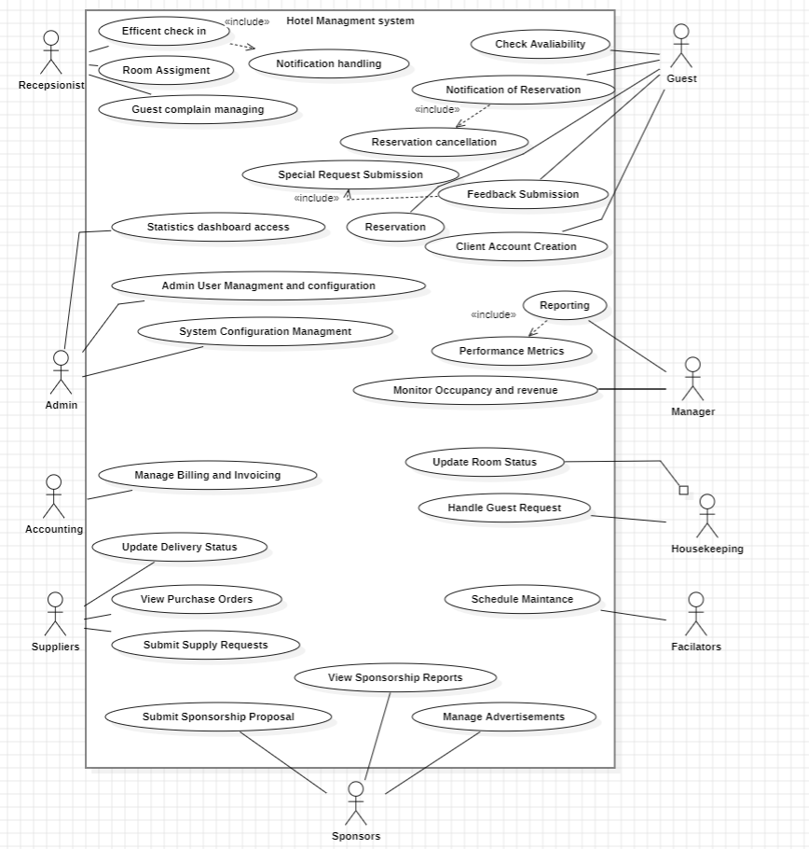

# **5. Diagram**

## **5.1 ERD Diagram**

## 

## **5.2 Activity Diagram**

**Check-In**

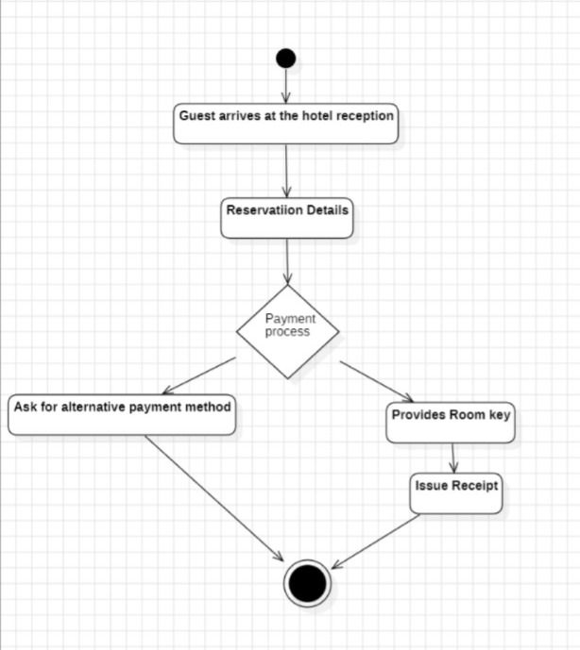

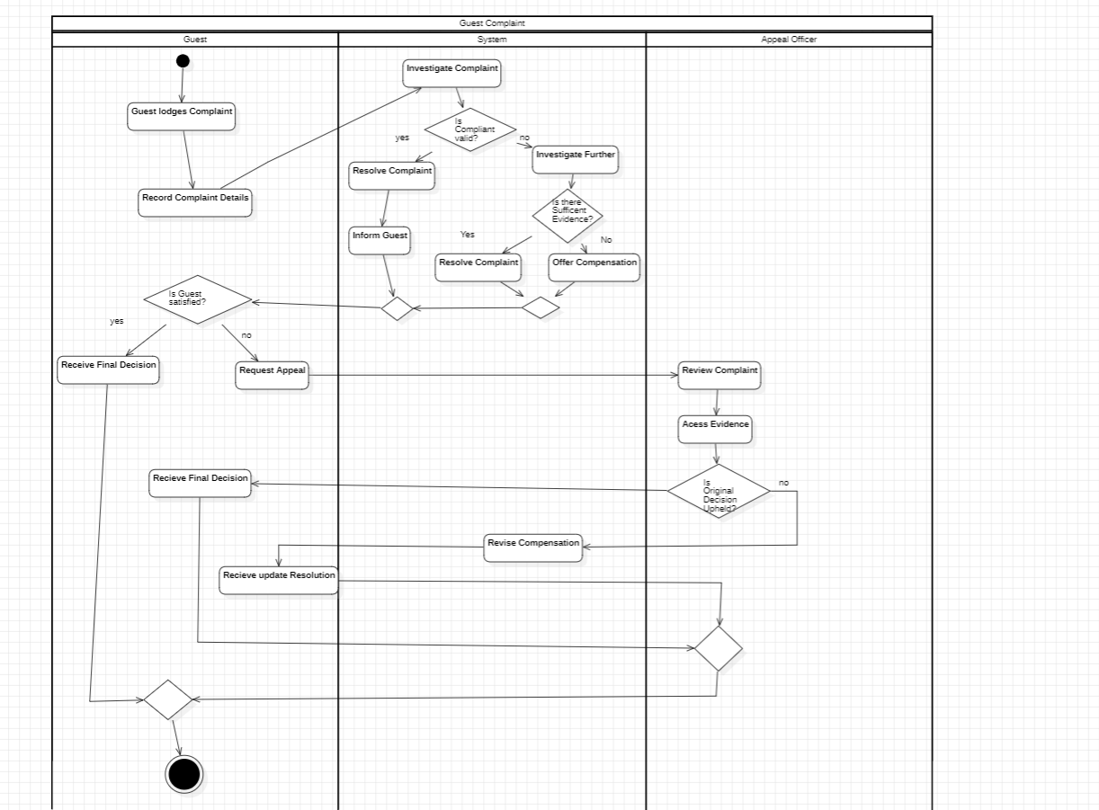

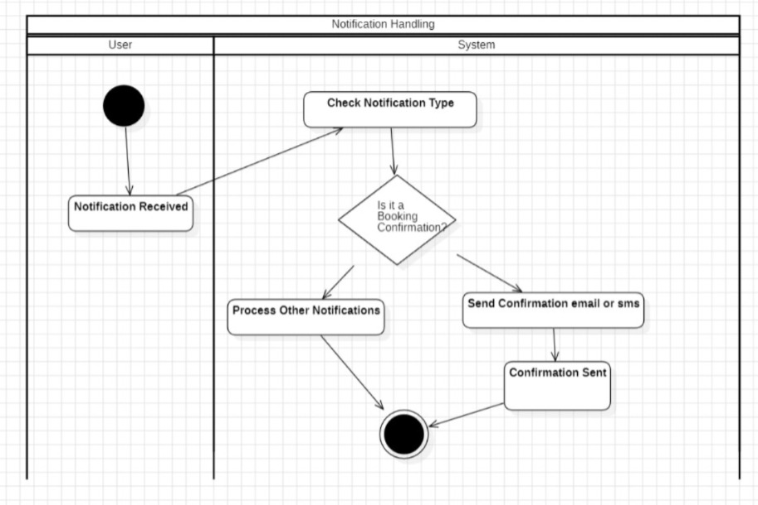

Room Assignment

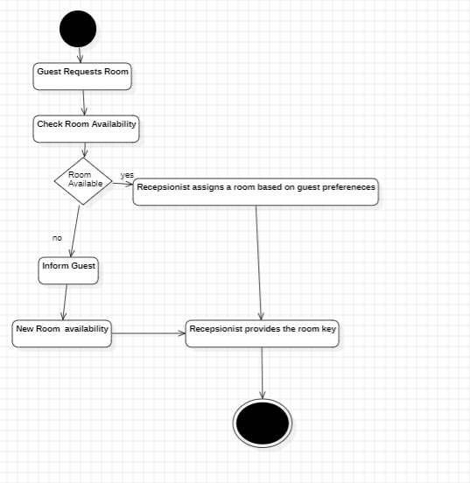

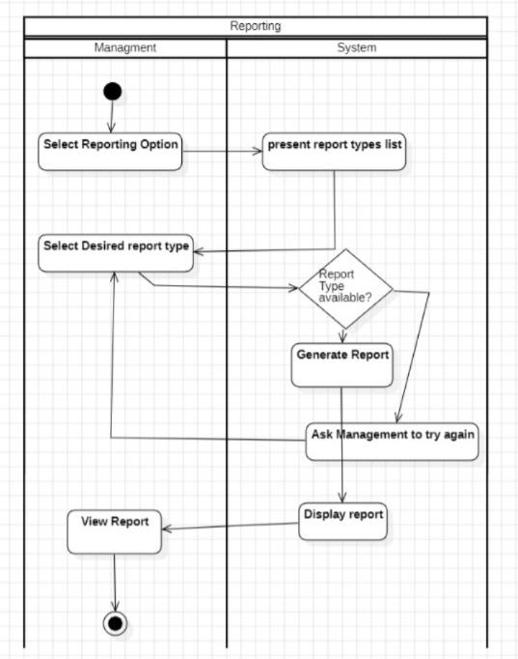

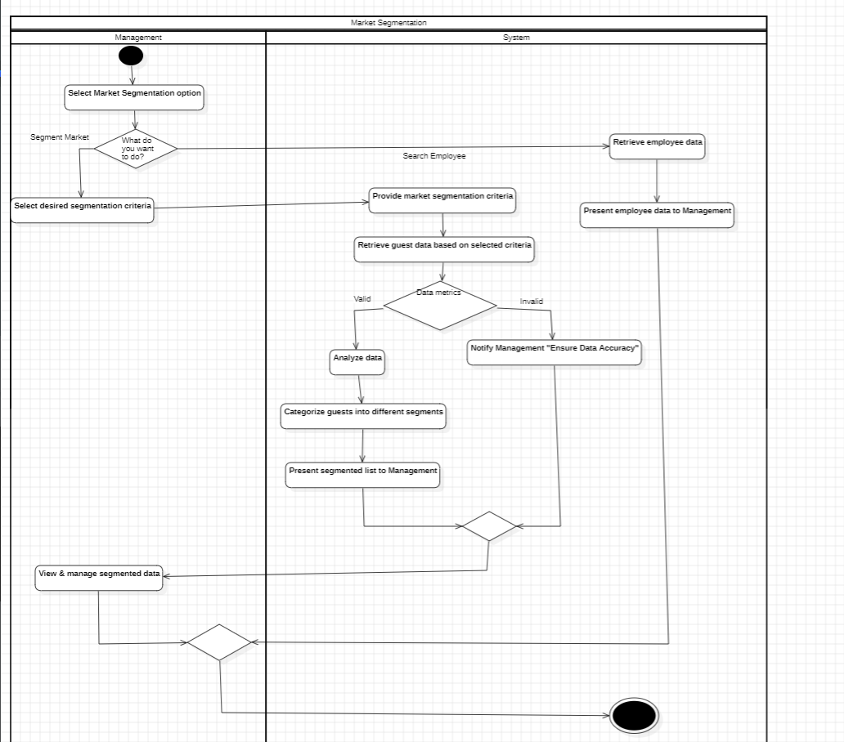

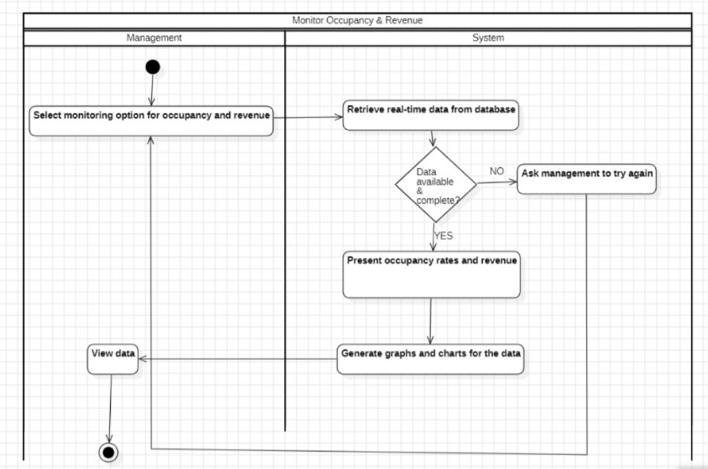

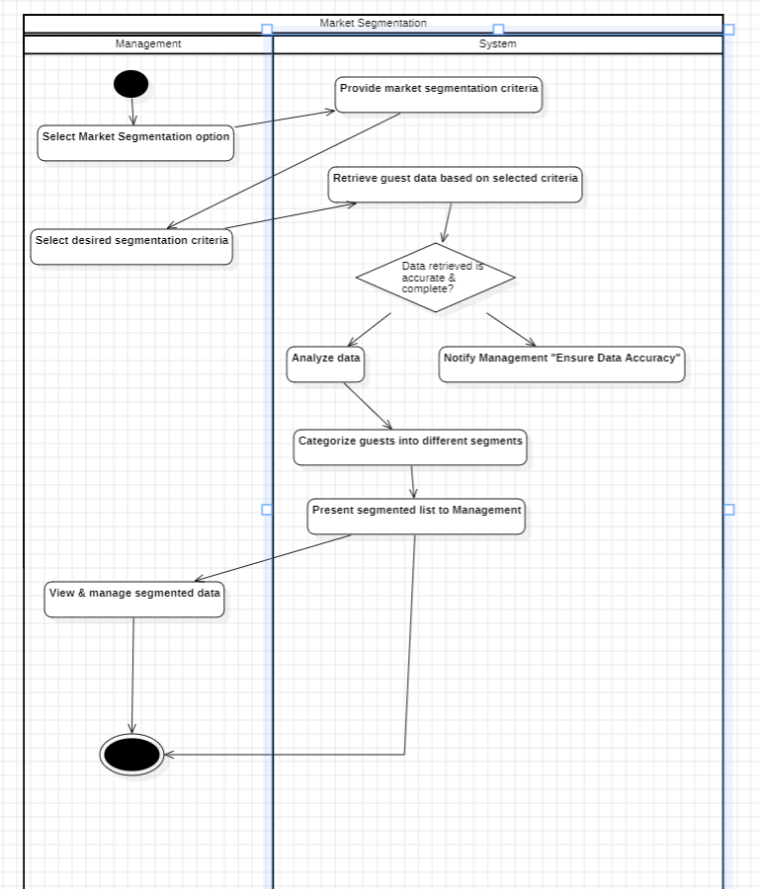

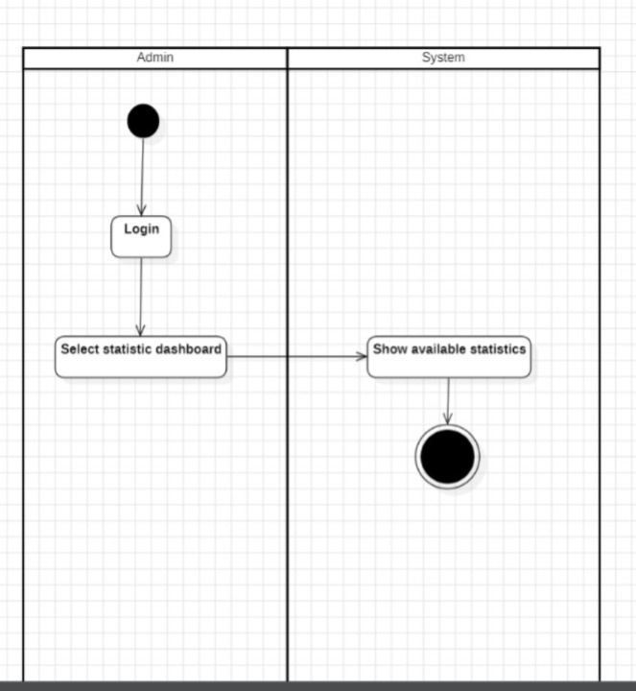

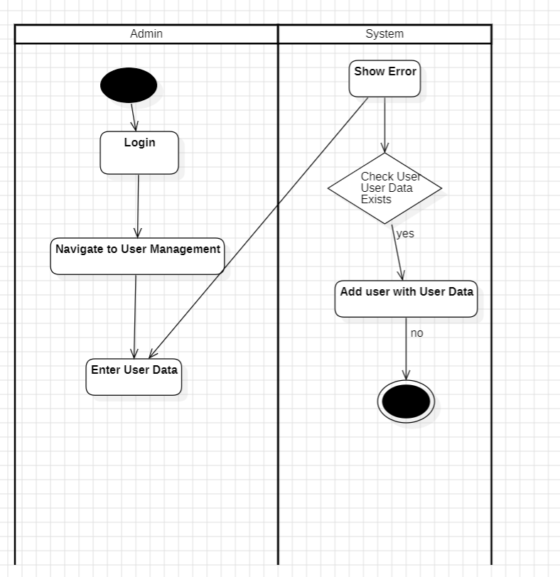

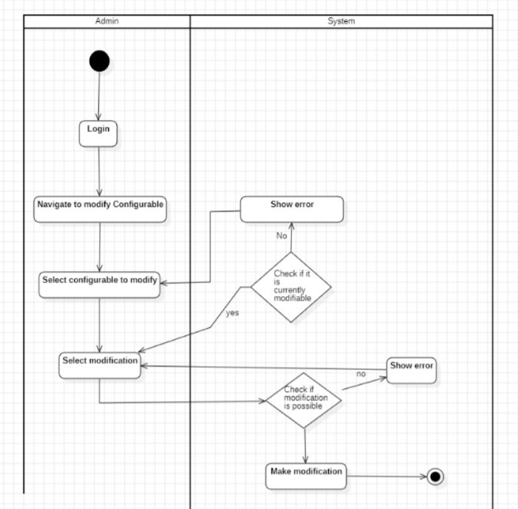

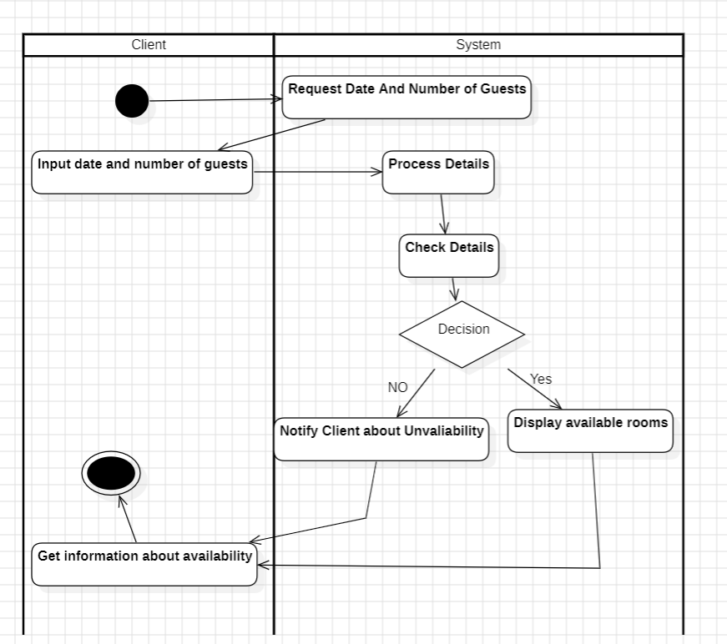

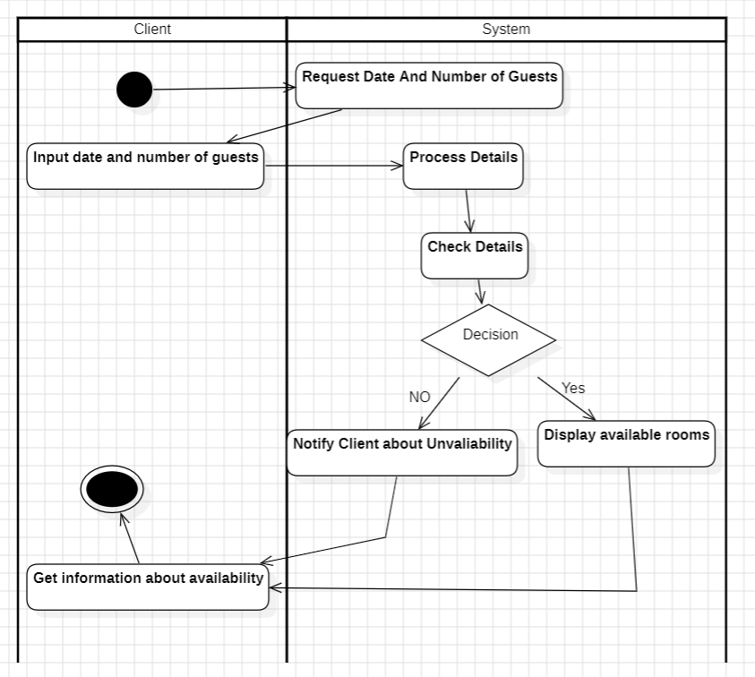

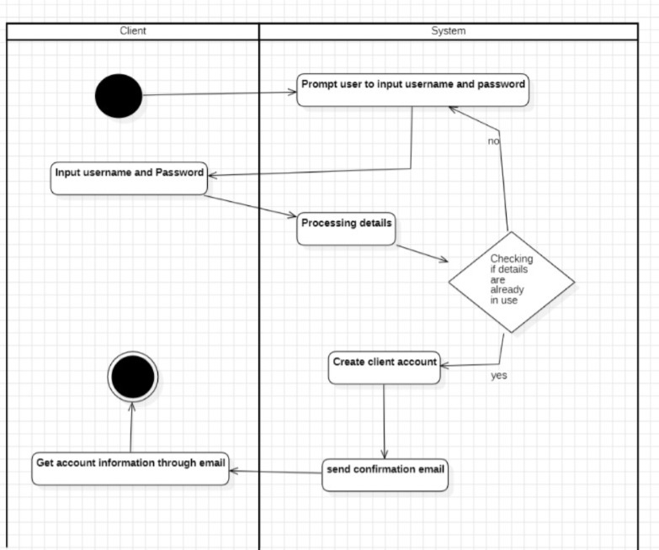

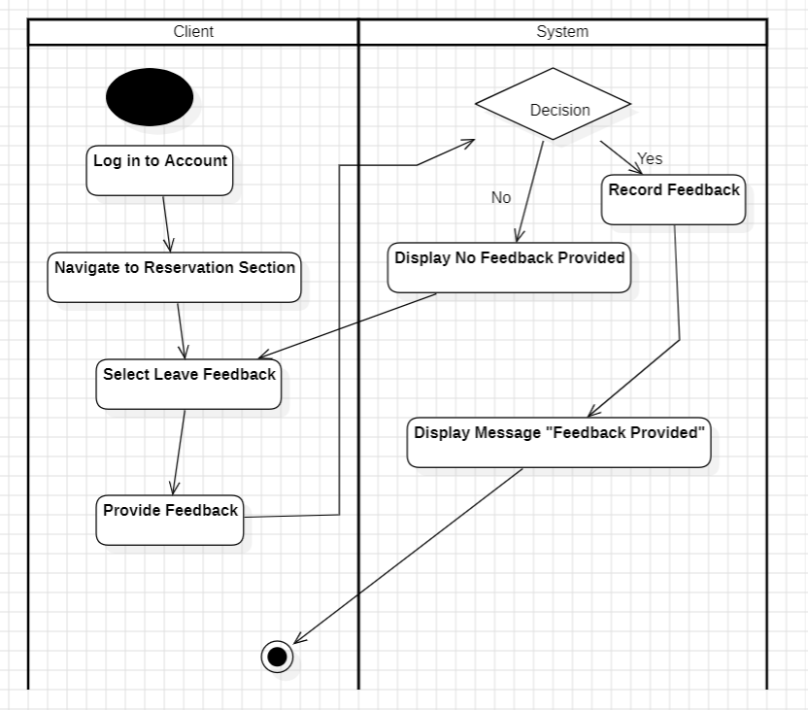

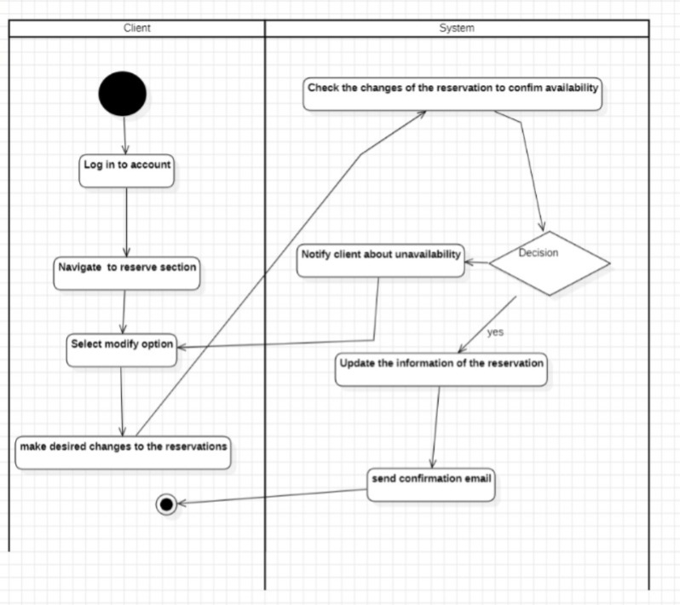

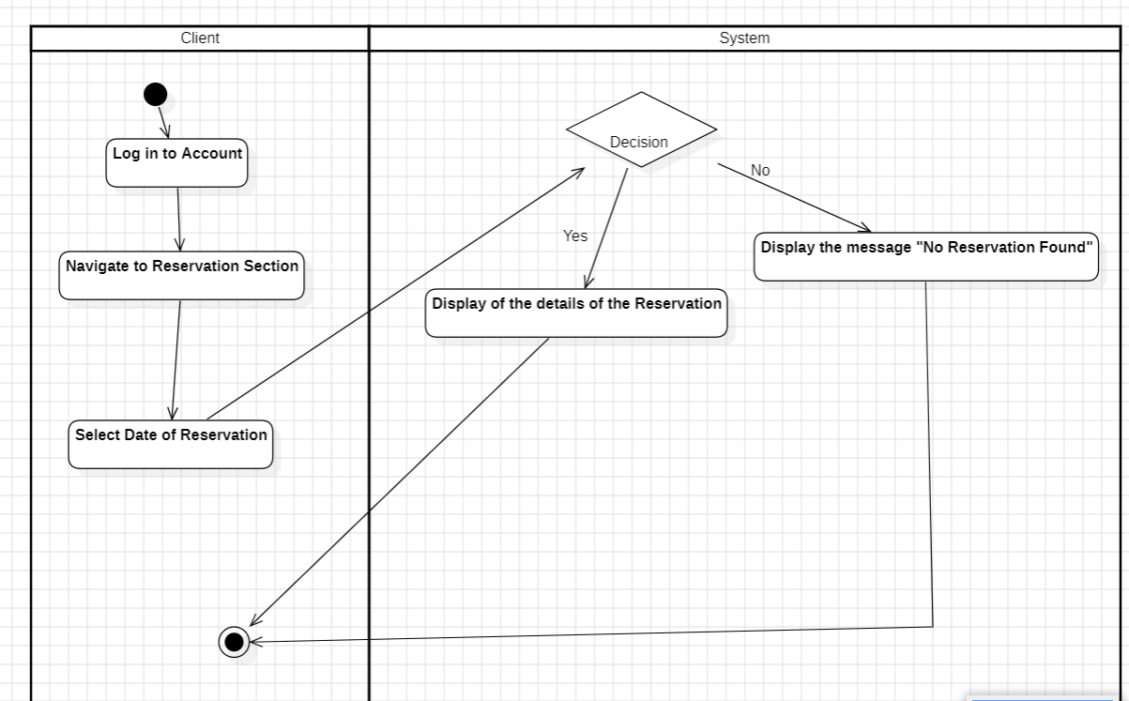

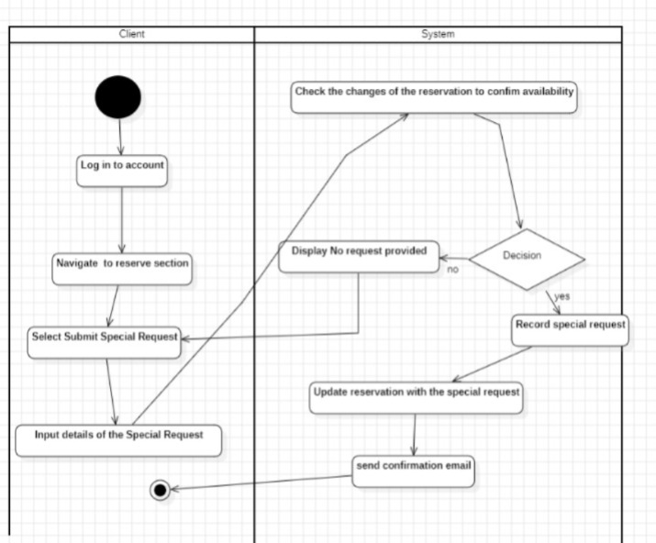

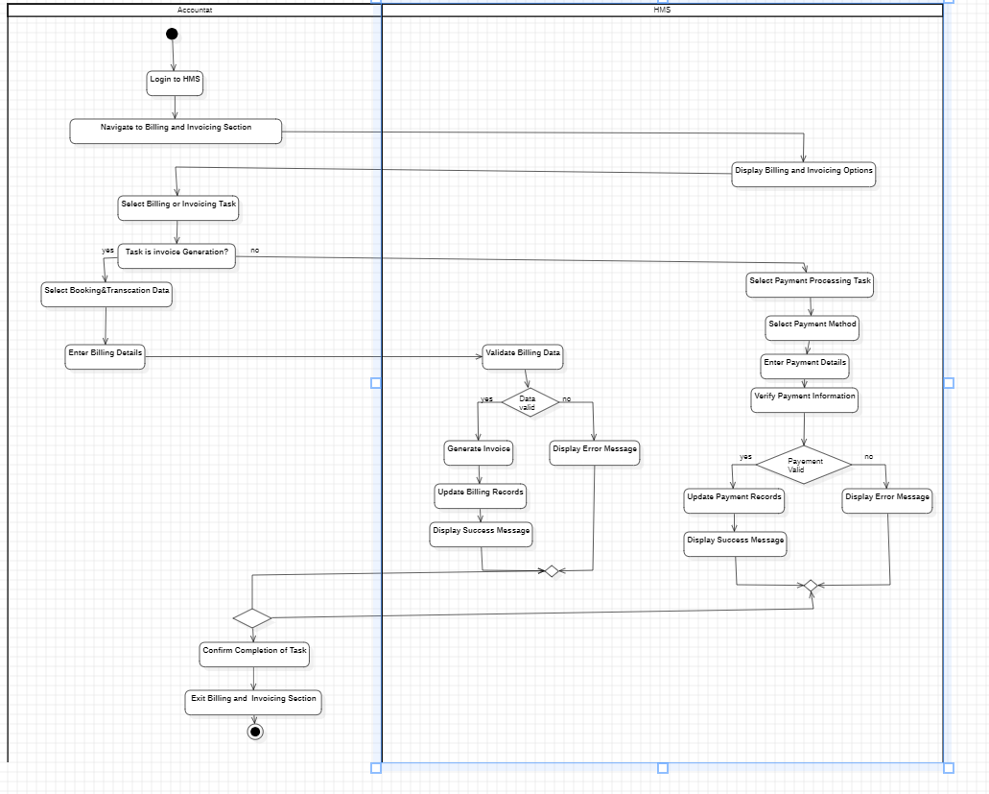

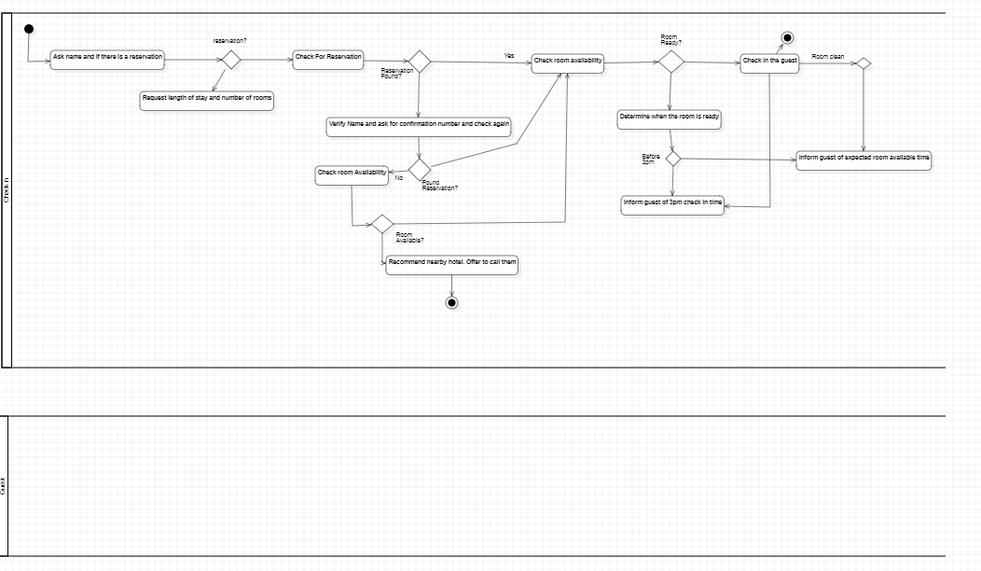

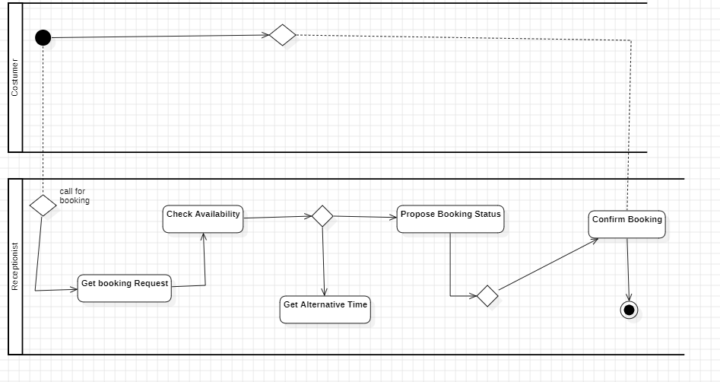

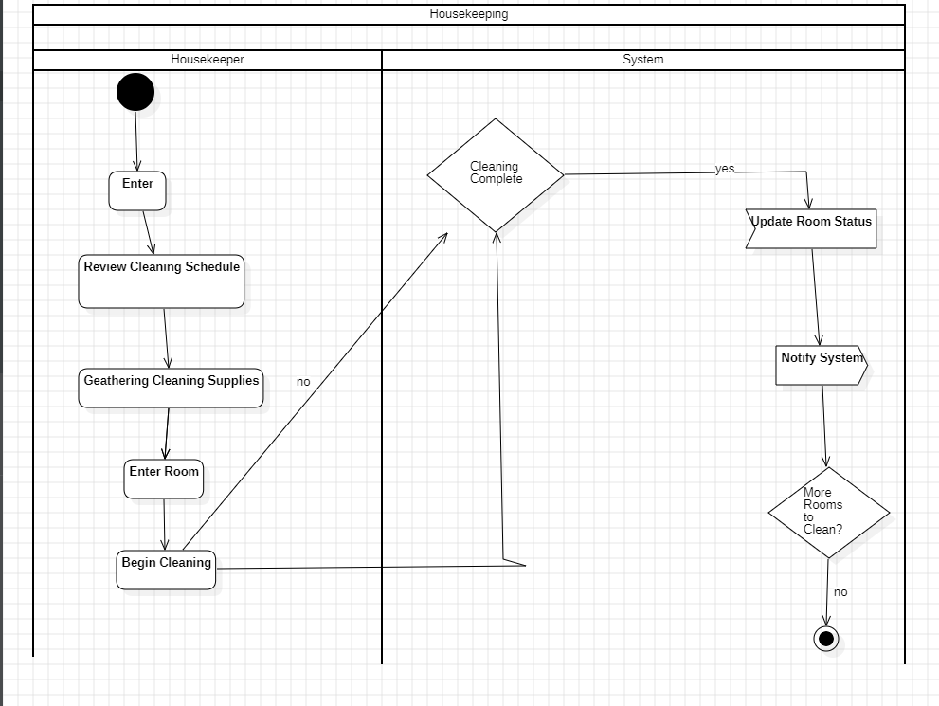

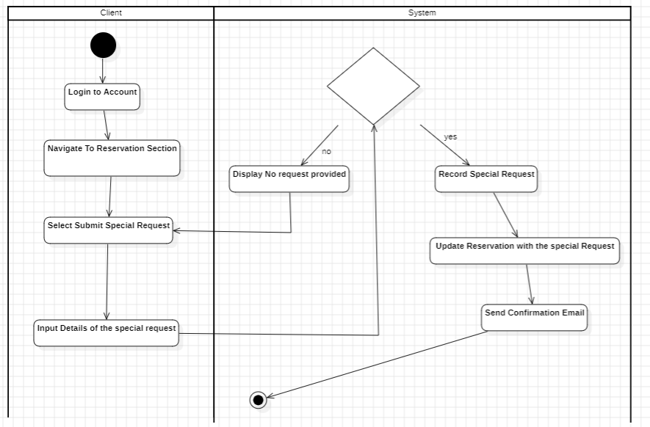

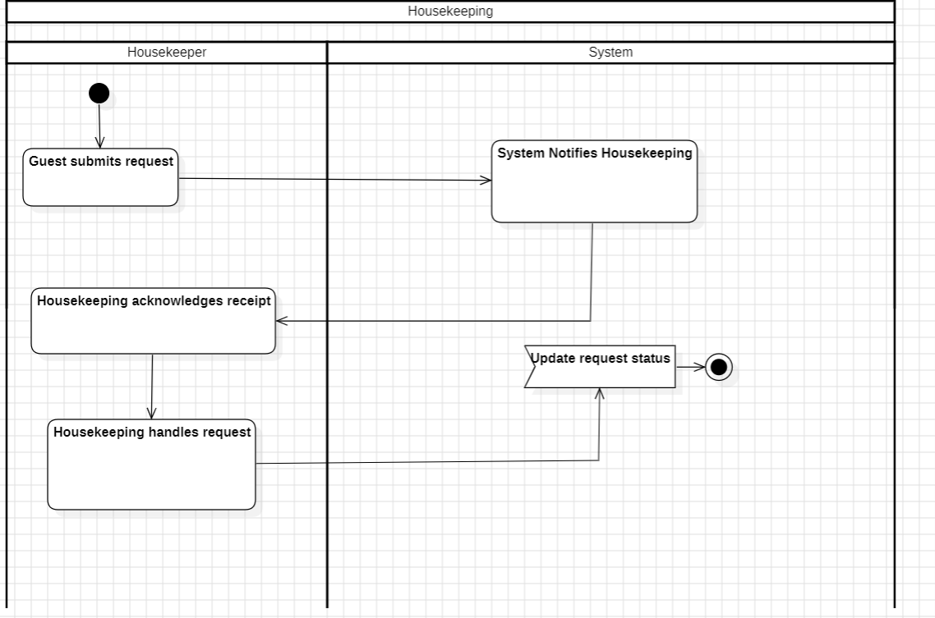

## **5.3 Class Diagram**

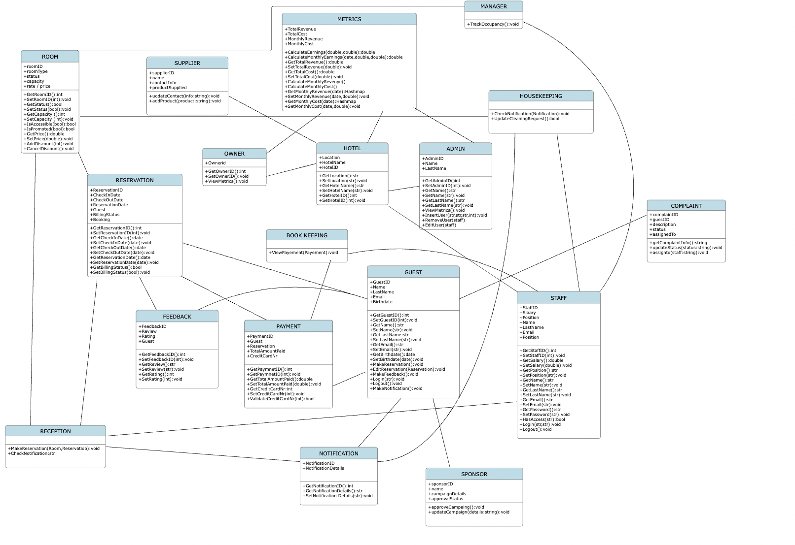**5.4 State Diagram**

##### **Guest**

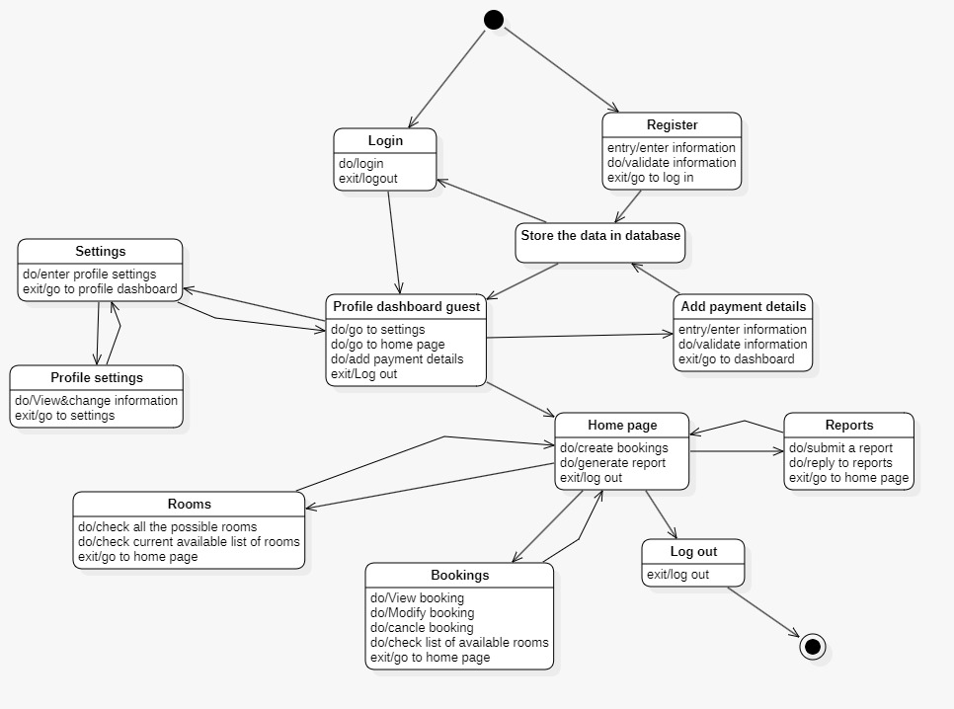

##### **Front Desk**

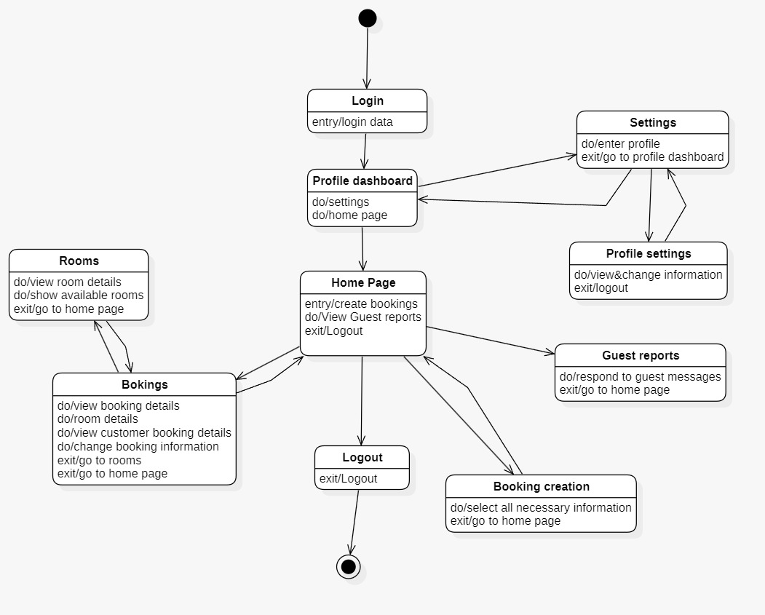

##### **Admin**

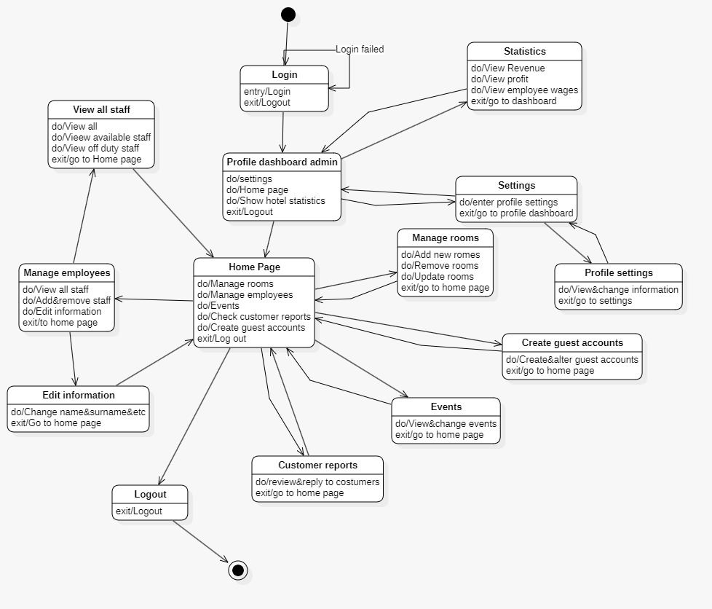

##### **Owner**

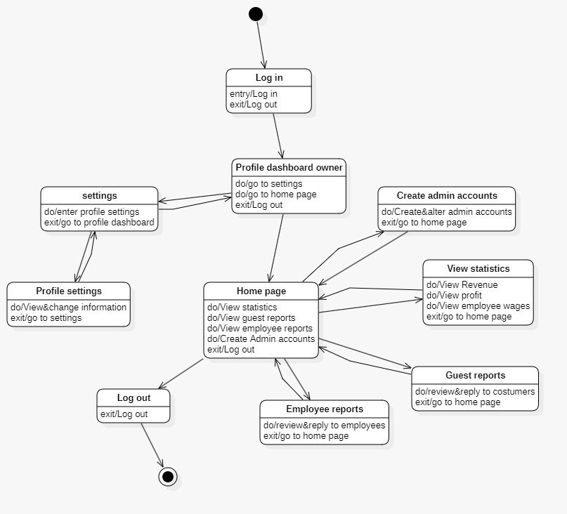

##### **5.5 Sequence Diagram**

### **Front Desk**

##### **Check IN & ROOM ASSIGNMENT**

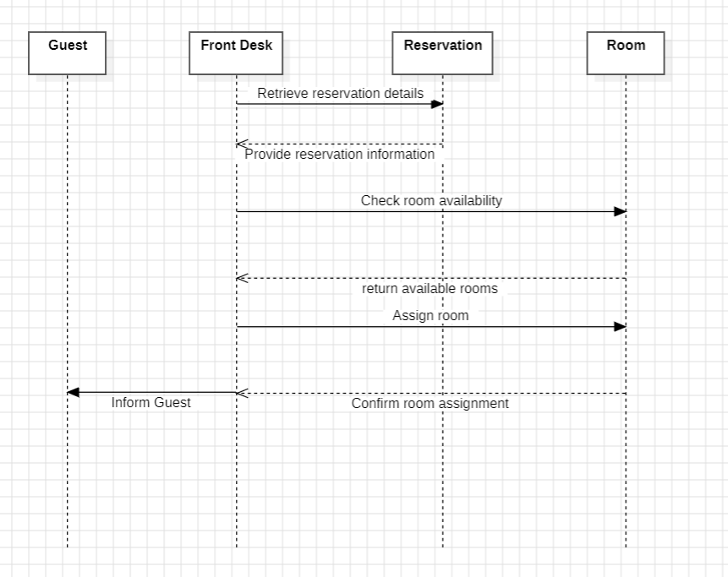

##### **Guest Complaint**



**Notification Handling**

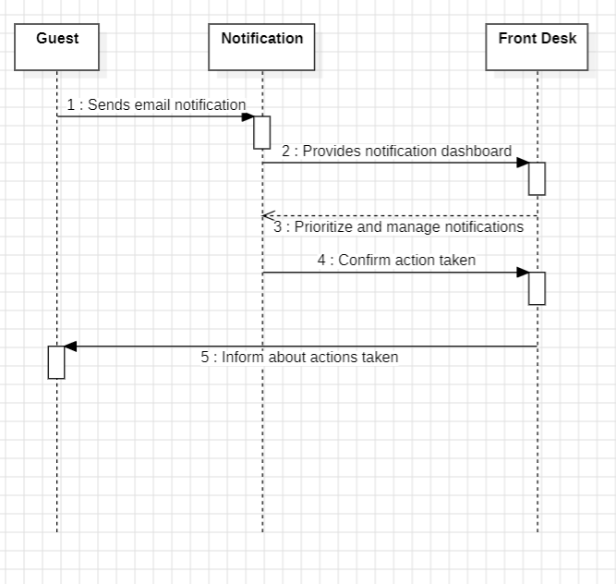

### **Admin & Owner**

##### **SYSTEM CONFIGURATION**

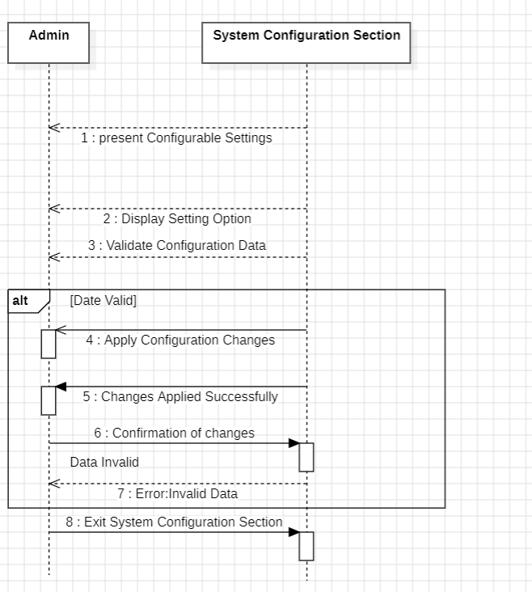

##### **Statistcs**

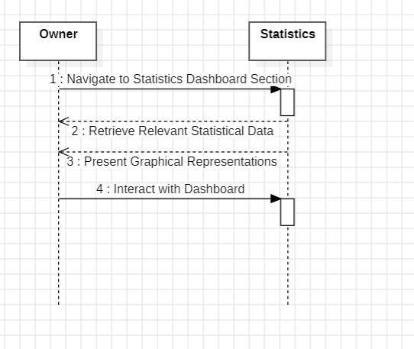

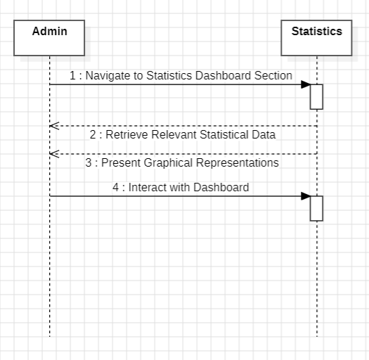

### **Manager/Administrator**

Market Segmentation

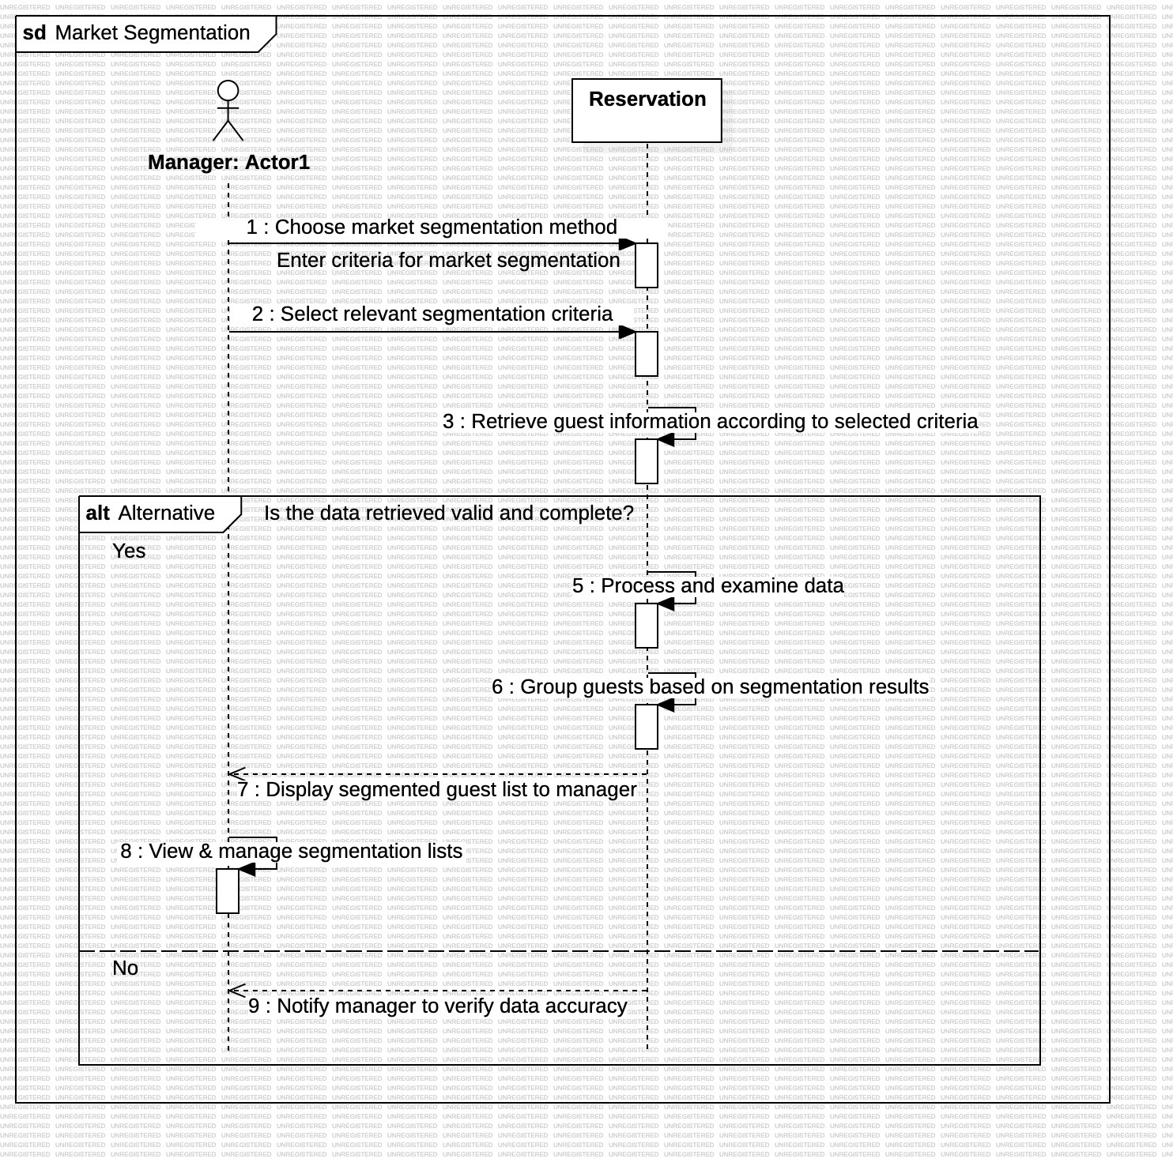

Occupancy and Revenue

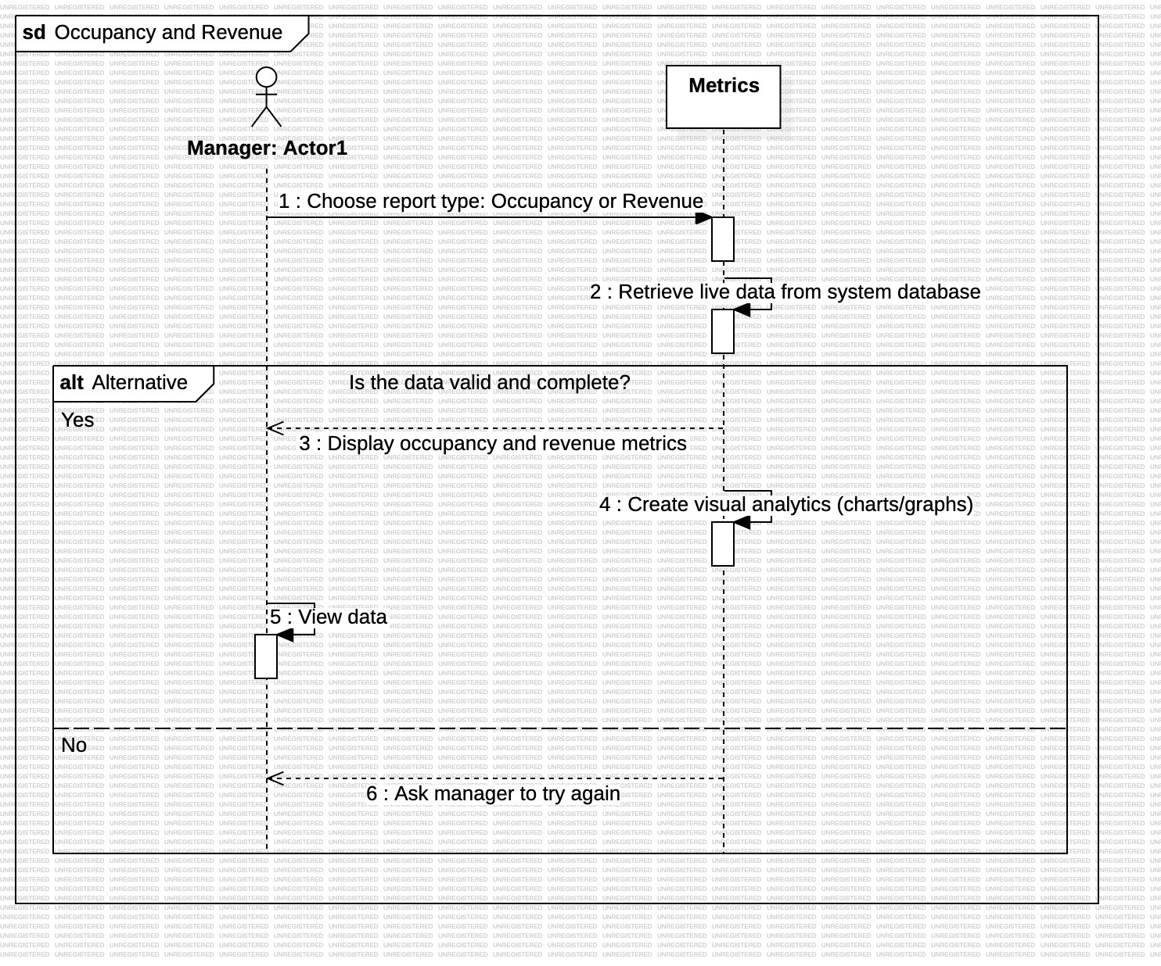

Occupancy and Revenue



Reporting

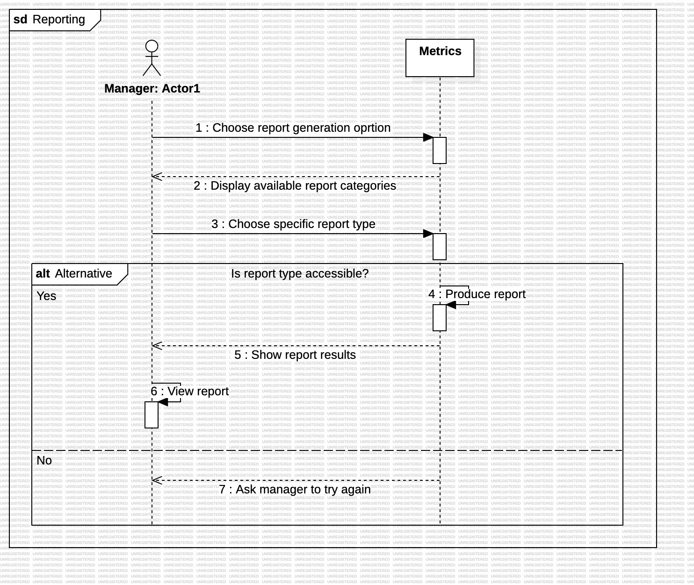

### **Client**

##### **Guest Registration**

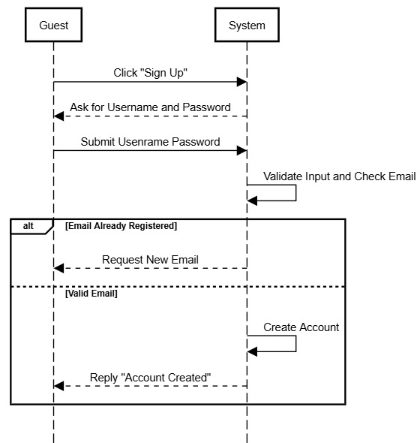

##### **Room Availability**

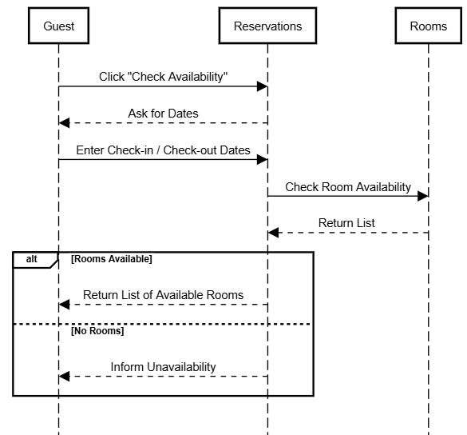

##### **Guest Feedback**

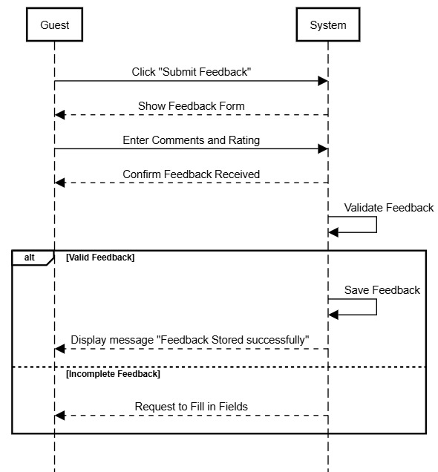

##### **Create Booking**

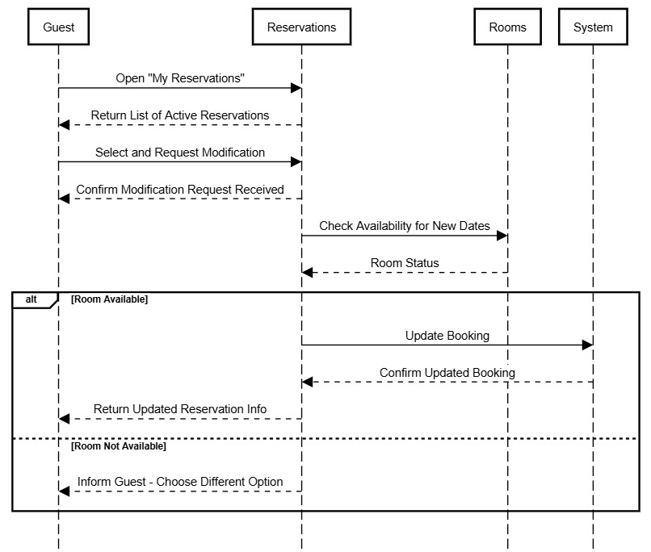

##### **Create Guest Special Request**

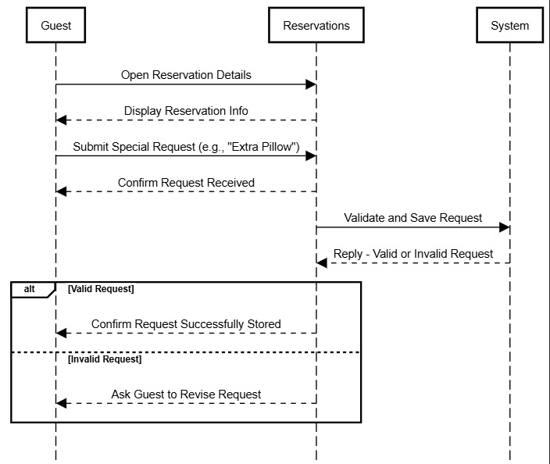

### **Housekeeper**

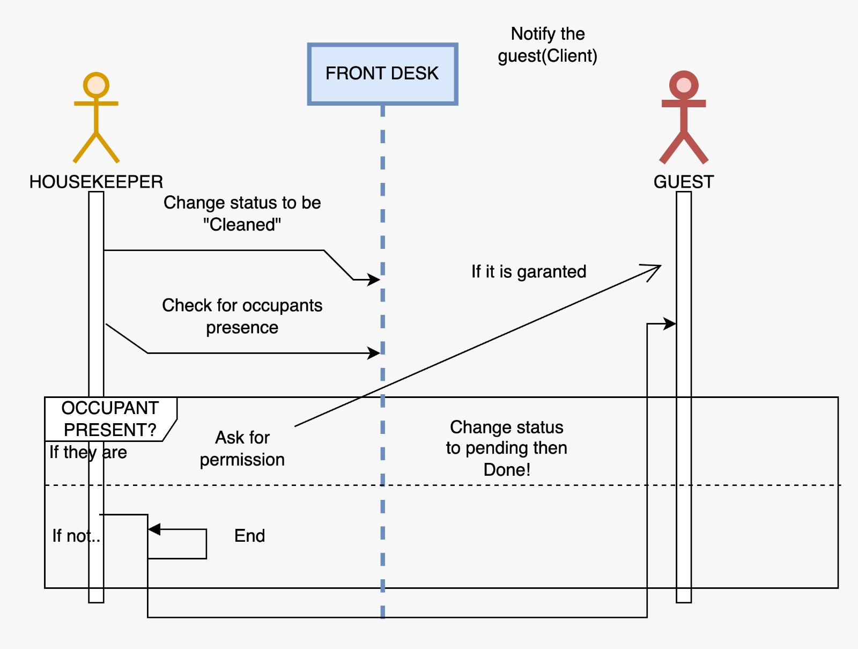

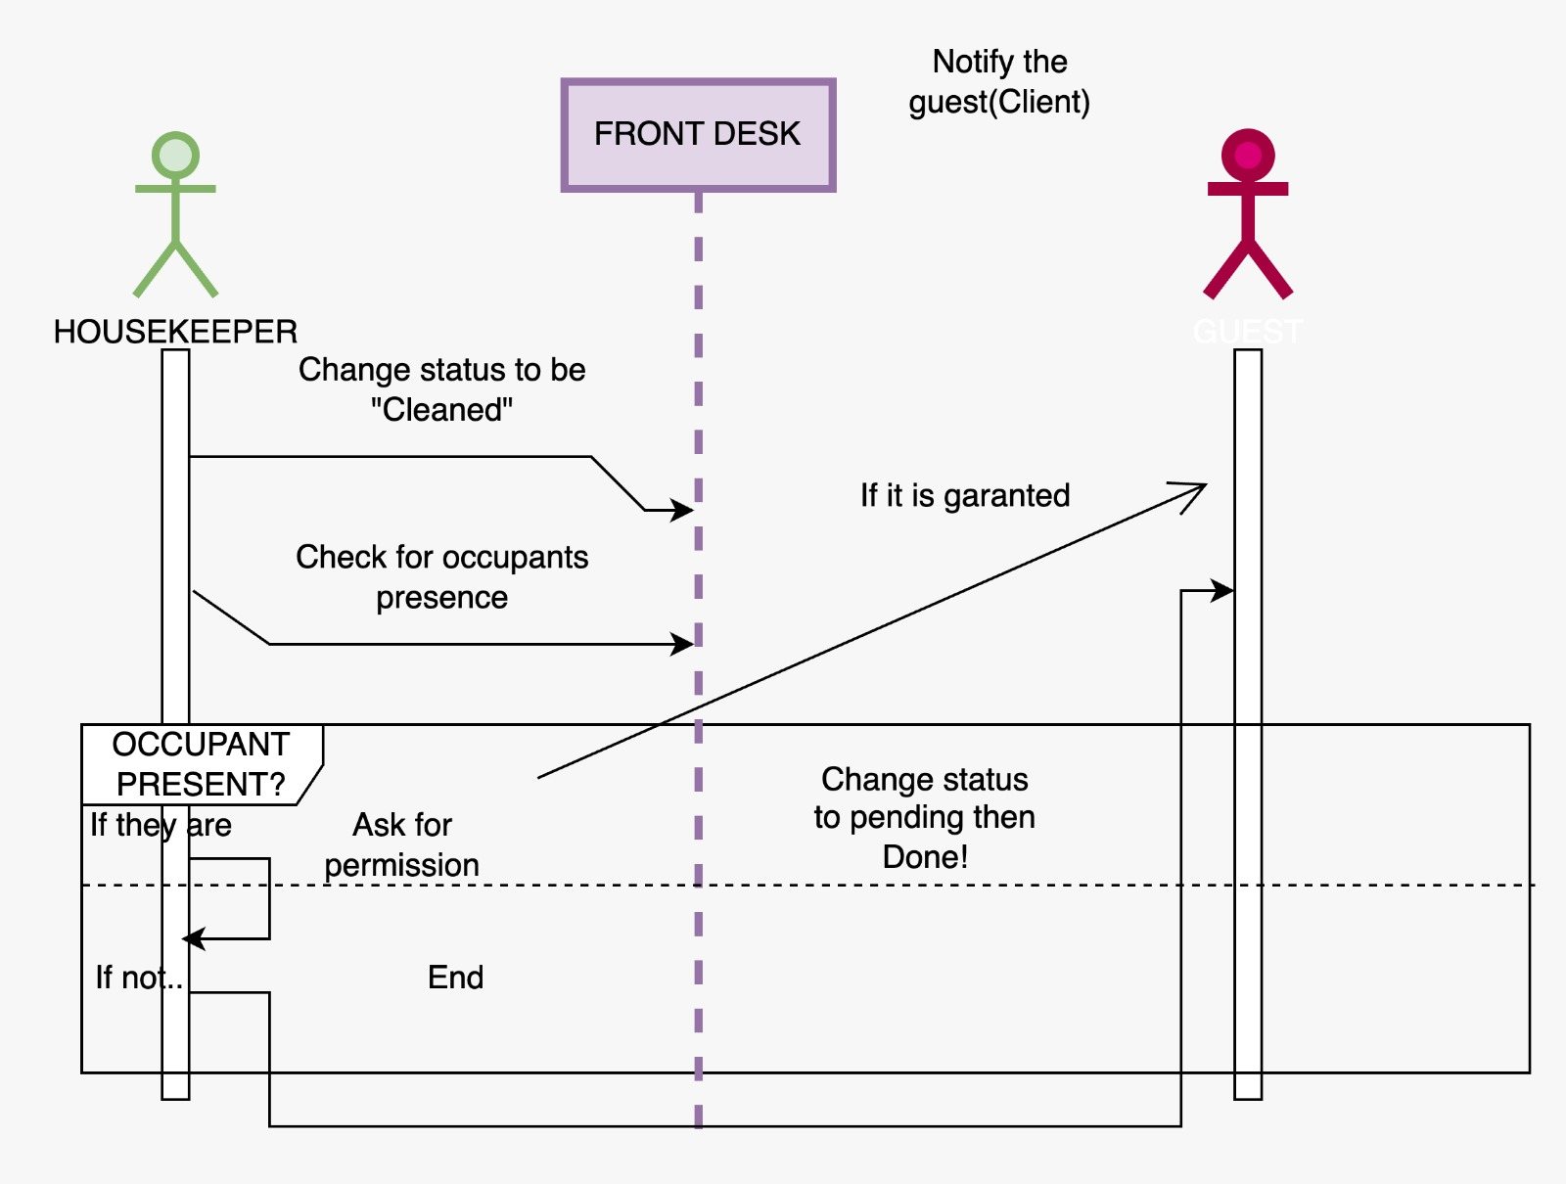

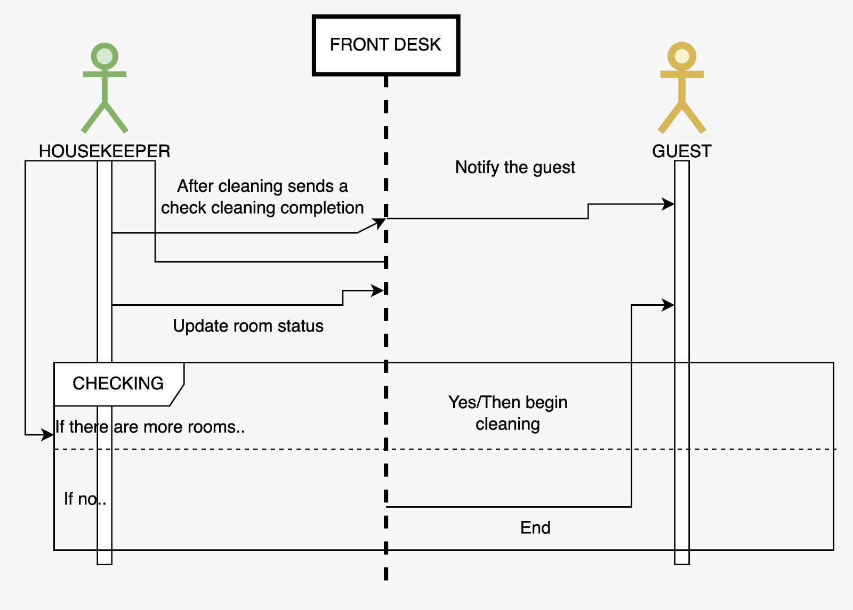

### **Accountant**

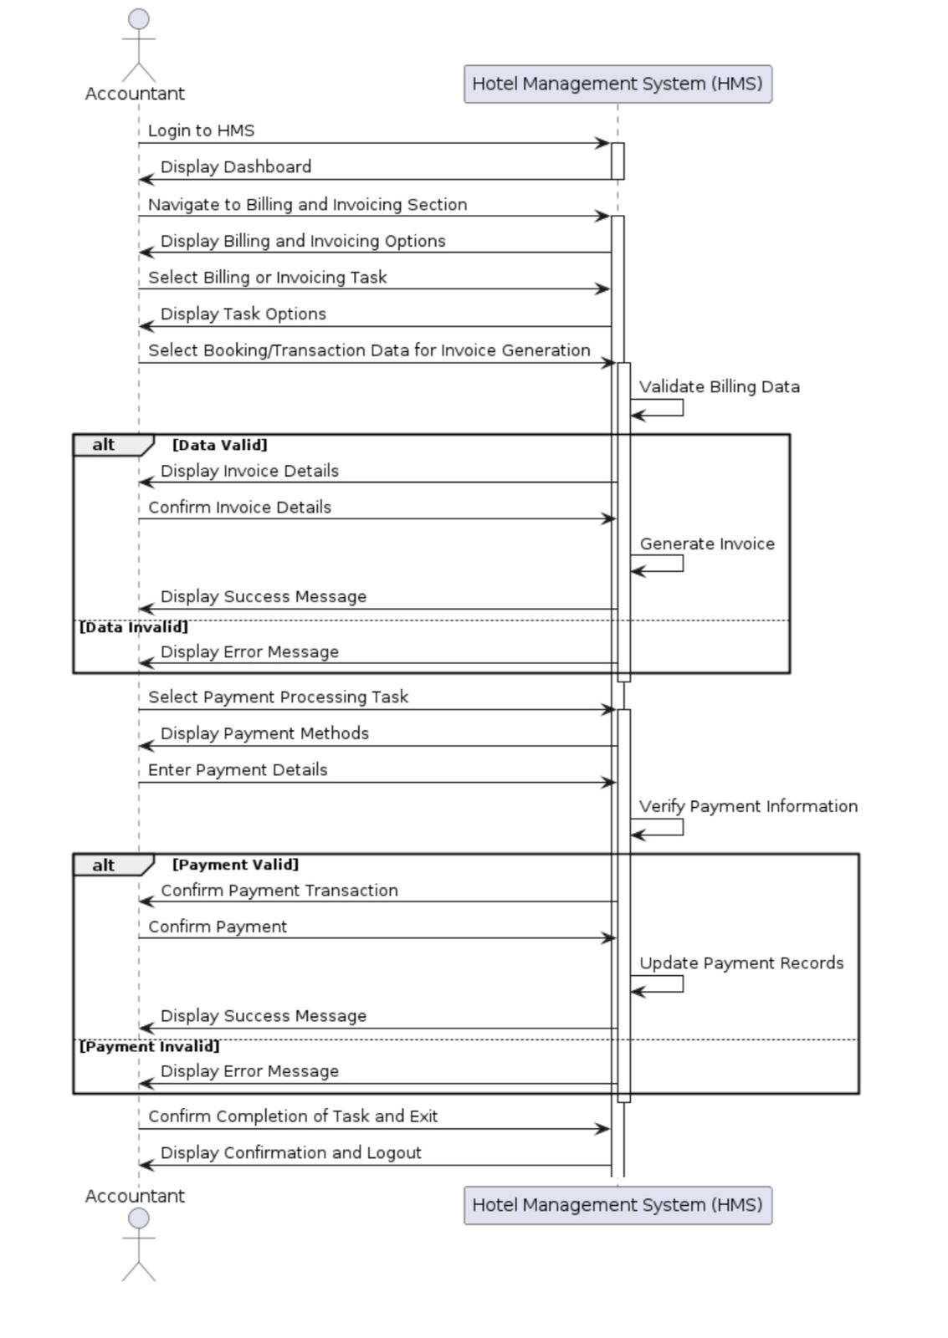

### **Sponsor**

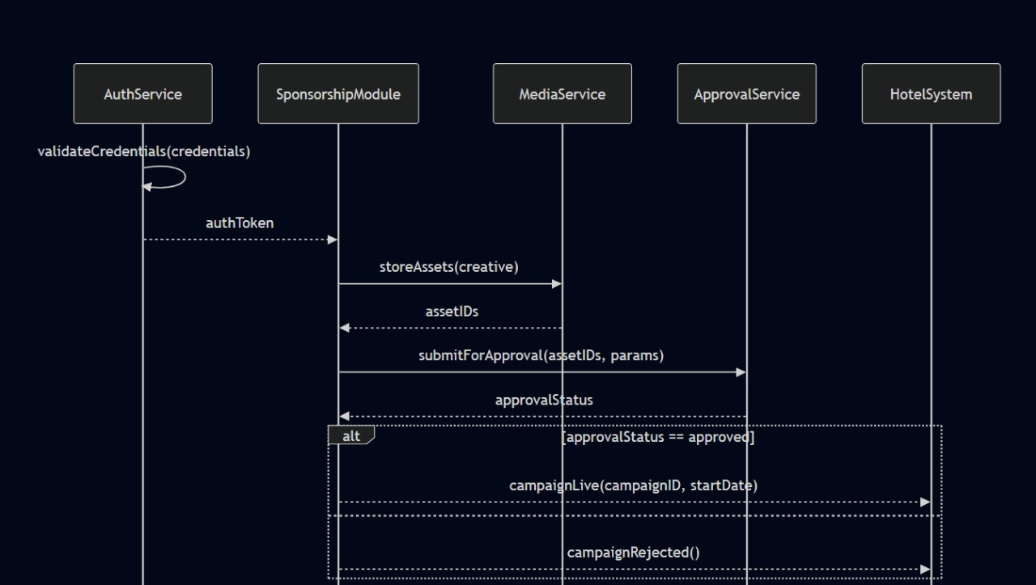

Supplier

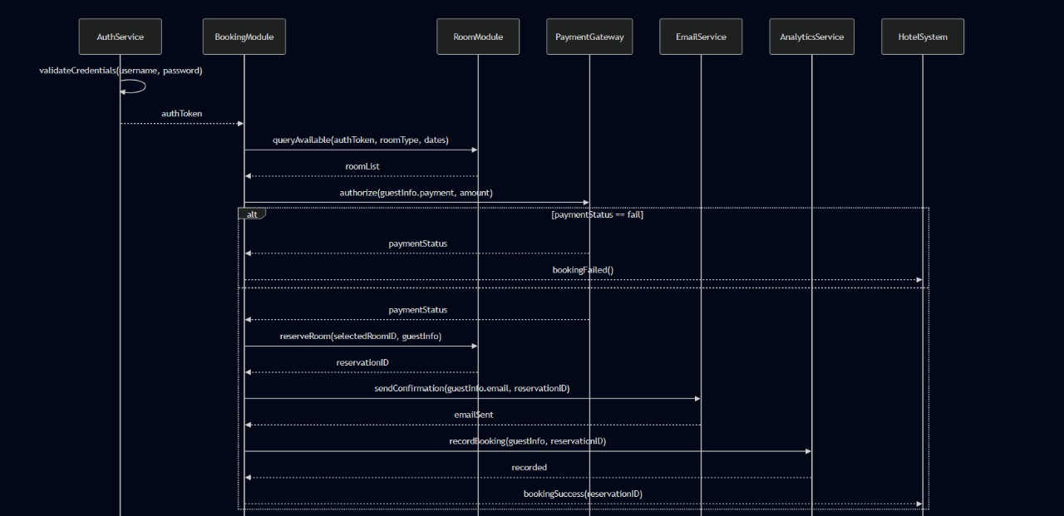

Staff

Order Module

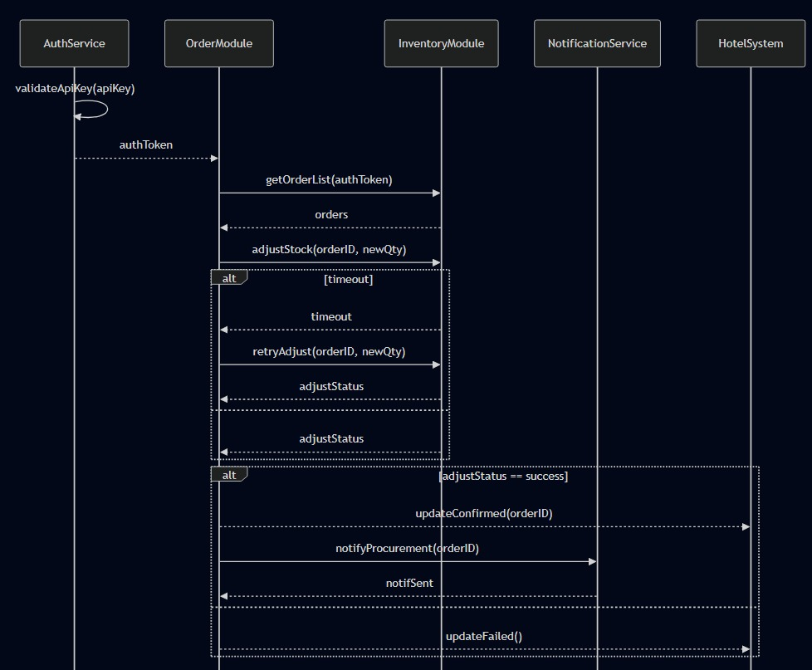

Housekeeping Module

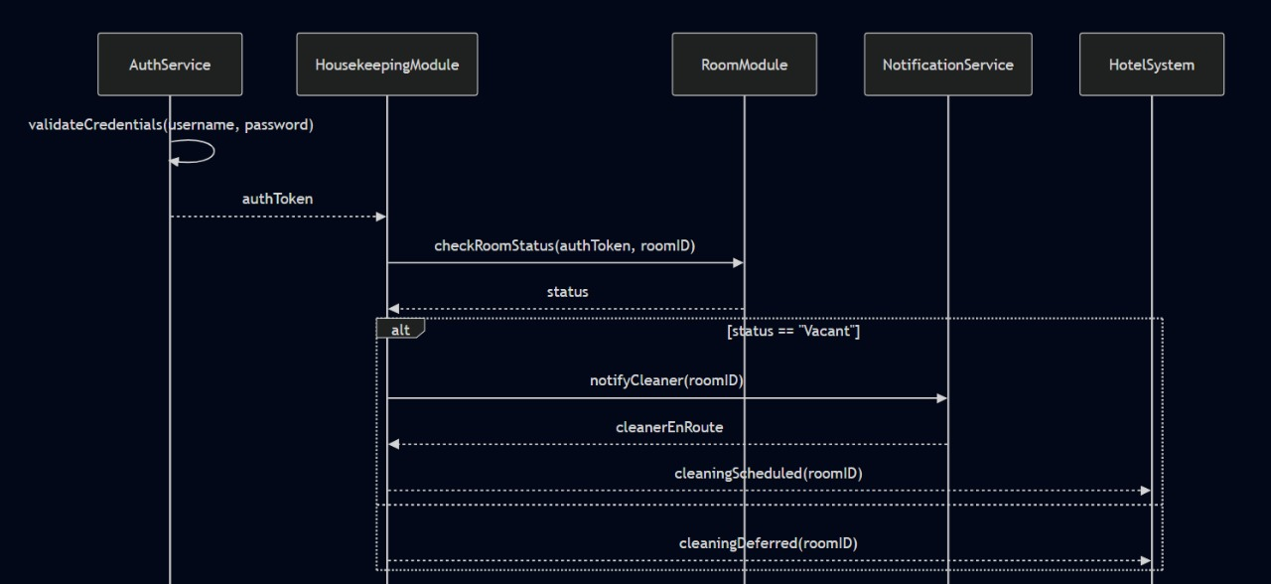

Kitchen Module

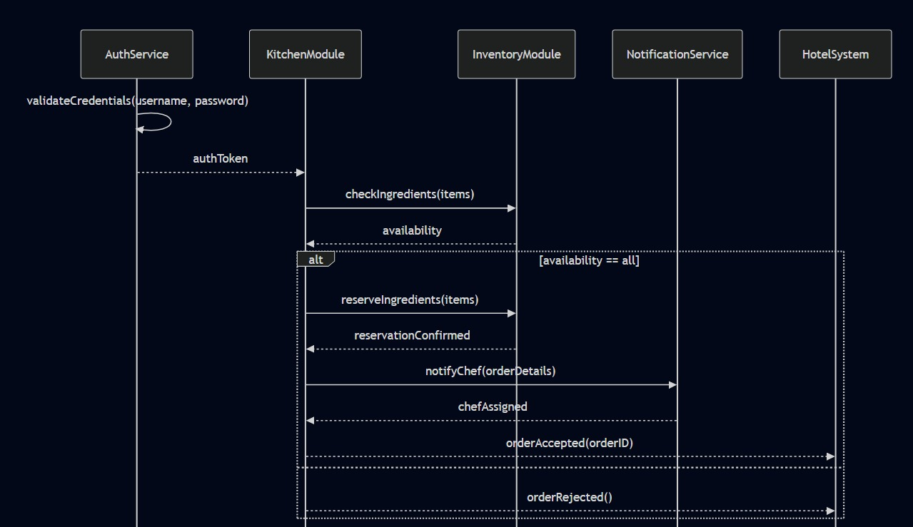

Valet Module

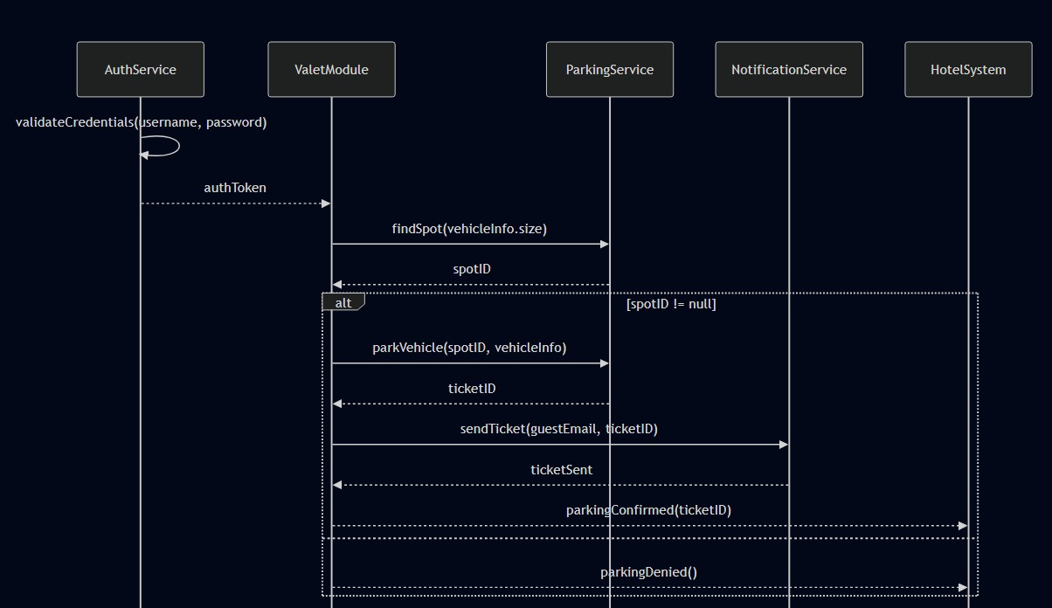

Spa Module

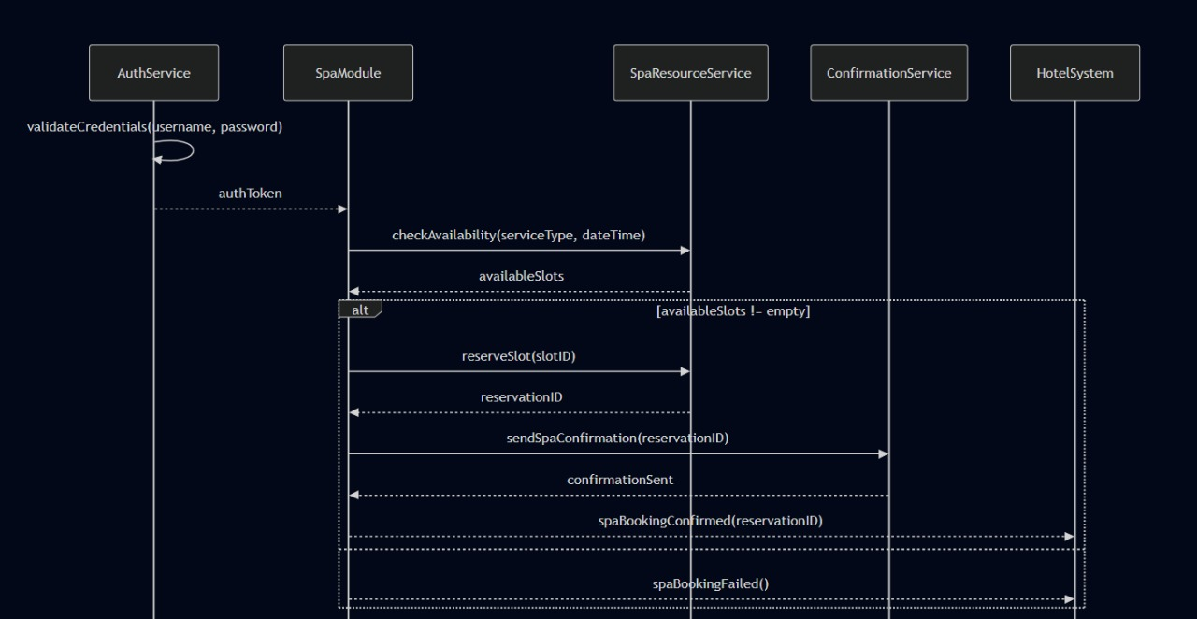

Concierge Module

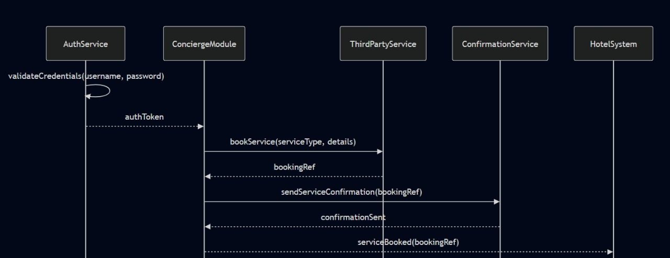

Complaints Module

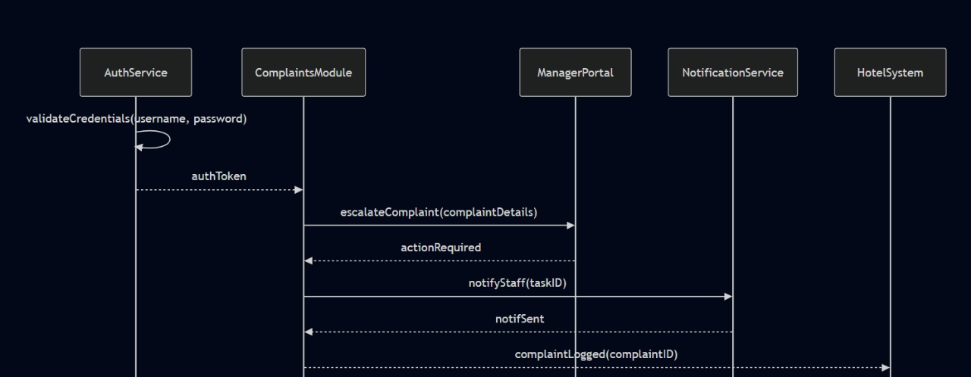

Admin Module

